Table of Contents

People and Projects 4

Address Book 5

Income Distribution 7

Income Distribution 7

Voucher Distribution 12

Expense Distribution 22

Vehicle Logs 22

Create Statement 28

Statement of Account 31

Other Expenses 37

Direct Bank Expenses 41

Configuration 44

Vehicles 44

Phone Lines 47

Phone Pins 49

Voucher Configurations 51

Bank and Cash 57

Bank Accounts 58

Bank Reconciliation 58

Check Clearing 58

Fund Transfer Clearing 62

Petty Cash 65

Monitoring 65

Bills Exchange 68

Replenishment 71

Transfers 74

Daily Transactions 74

Fund Transfer 74

Internal Bank Transfers 74

Internal Account Transfers 74

Bank Transfers 74

Checks 74

Check Payments 74

Check Monitoring 74

Exchanges 74

Configuration 74

Currencies 74

Denominations 74

Banks 74

Accounting 76

Journal Entries 77

Journal Vouchers 77

Journal Entries 77

Journal Items 77

Analytic Journal Items 77

Charts 77

Chart of Accounts 77

Chart of Analytic Accounts 77

Periodical Processing 77

*Draft Entries 77

*Reconciliation 77

Opening Balance 77

*Statements 77

*Recurring Entries 77

End of Period 77

Fund Allocation 77

Revaluations 77

Reporting 77

Statement of Accounts 77

Regional Reports 78

Configuration 78

Financial Accounting 78

Analytic Accounting 78

ACCPAC Extension Tools 78

Miscellaneous 78

Administration 78

# People and Projects

## Address Book

1. Purpose

The address book serves as the table of the contact details of missionaries and project accounts. It is being referred on by the analytic accounts and the SOA sending functionality for email references.

1. Views
   1. **List View**

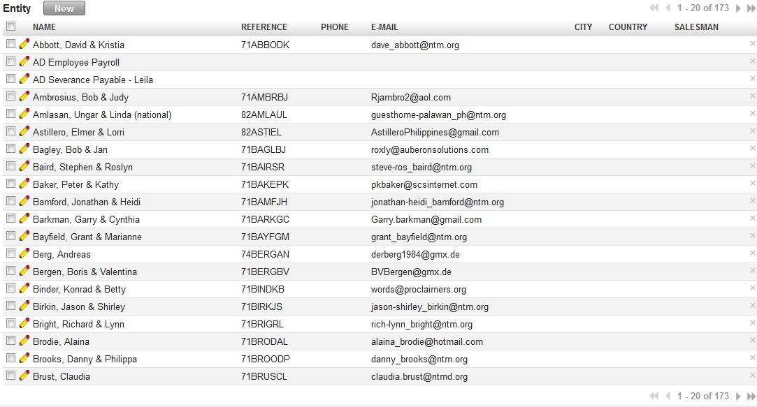

Figure - List View of Address Book (All Menus under Address Book)

* 1. **Form View**

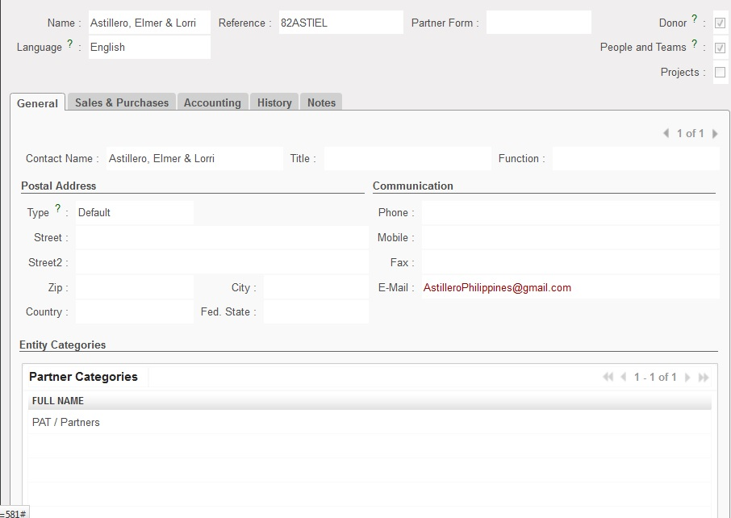

Figure - Form View of Address Book (All Menus under Address Book)

1. Menu and Access Right
   1. Menu – People and Projects > Address Book > [People and Teams Information, Projects Information]
   2. Access Rights
2. Required Fields
3. Workflow
4. User Action
5. Field Visibility
6. Reports and Prints Outs
7. Errors

## Income Distribution

### Income Distribution

1. Purpose

All income that needs to be distributed shall be processed using income distribution. Income Distribution will automatically create the journal entries upon completion of the process.

1. Views
   1. **List View**

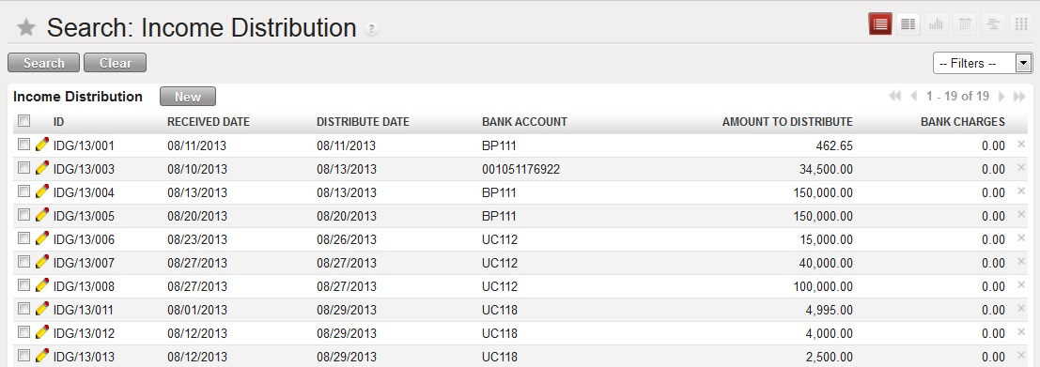

Figure - List View of Income Distribution

* 1. **Form View**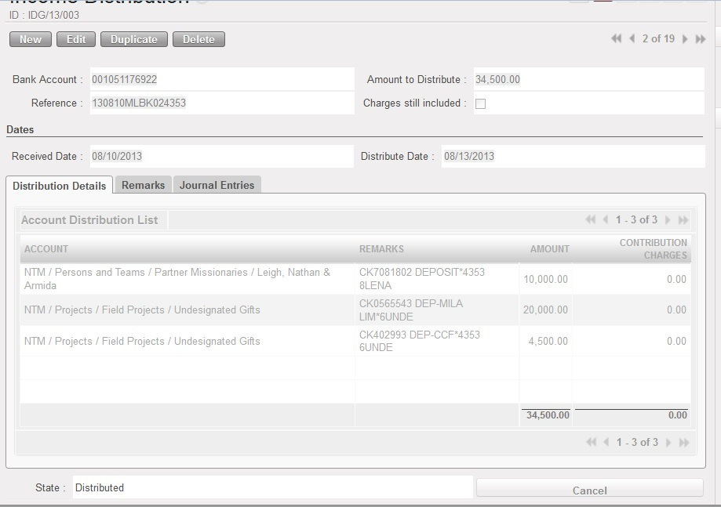

Figure - Form View of Income Distribution (Distribution Details Tab)

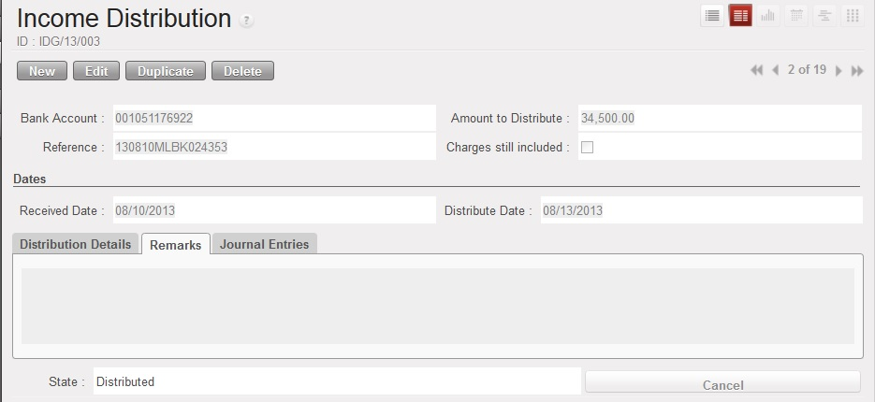

Figure - Form View of Income DIstribution (Remarks Tab)

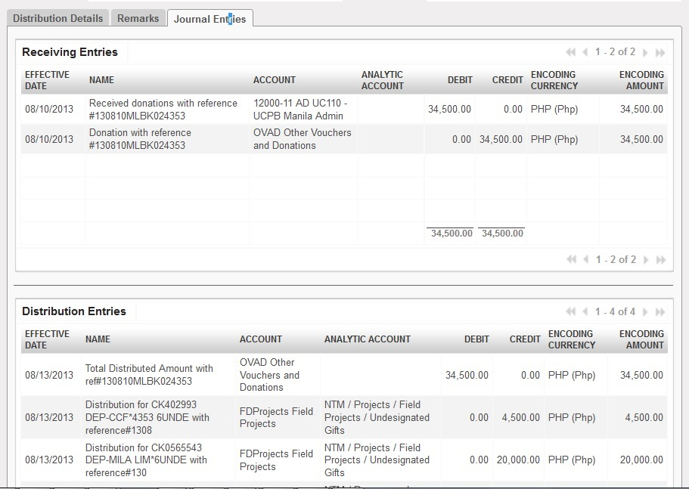

Figure - Form View of Income DIstribution (Journal Entries Tab)

1. Menu and Access Right
   1. Menu – People and Projects > *Income Distribution*> *Income Distribution*
   2. Access Rights

|  |  |  |  |  |
| --- | --- | --- | --- | --- |
| **Role** | **Read** | **Write** | **Create** | **Delete** |
| **Income Distribution Manager** | Yes | Yes | Yes | No |

1. Required Fields (required by State)

|  |  |
| --- | --- |
| **Field Name** | **Required in** |
| **Bank Account** | Draft |
| **Amount to Distribute** | Draft |
| **Reference** | Draft |
| **Received Date** | Draft |
| **Bank Charges** | Draft (Charges still included = True ) |
| **Distribute Date** | Money Received |

1. Workflow



Figure Workflow of Income Distribution Process

|  |  |  |
| --- | --- | --- |
| **State** | **Description** | **Visible Buttons** |
| **Draft** | Initial state of the record. User will encode the details of the received money. | **Receive Money** |
| **Money Received** | Money has been received to the bank.  This will also be the state clicking the ‘**Cancel Distribution Transaction**’ button during the ‘**Received Money Distributed**’ | **Cancel Receiving Transaction**  **Distribute Donation** |
| **Received Money Distributed** | Record has been reviewed by the Branch manager | **Cancel Distribution Transaction**  **Cancel Transaction** |
| **Transaction Cancelled** | The record will be in ‘**Cancelled**’ state when:   1. The ‘**Cancel Receiving Transaction**’ button is clicked. 2. The ‘**Cancel Transaction**’ button is clicked. |  |

1. User Action

|  |  |  |
| --- | --- | --- |
| **Button** | **Action** | **Triggred By** |
| **Receive Money** | Creates journal entries for the receiving part of the transaction. | **Income Distribution Manager** |
| **Cancel Receiving Transaction** | Removes the created JEs for the received money.  Set the state to ‘**Transaction Cancelled**’. | **Income Distribution Manager** |
| **Distribute Donation** | Creates JEs for the distribution part of the transaction. | **Income Distribution Manager** |
| **Cancel Distribution Transaction** | Removes the created JEs for the distribution transaction.  Set the state to ‘**Money Received**’. | **Income Distribution Manager** |
| **Cancel Transaction** | Removes the created JEs for the distribution and receiving transaction.  Set the state to ‘**Transaction Cancelled**’ | **Income Distribution Manager** |

1. Field Visibility

All fields are available for the Income Distribution Manager.

1. Reports and Prints Outs

No Available Reports/Print Outs

1. Errors

|  |  |  |
| --- | --- | --- |
| **ERROR CODE** | **MESSAGE** | **SOLUTION** |
| ERR-001 | *If Charges are still included, bank charges must be greater than 0.00!* | Bank Charges must always be greater than equal to ZERO before clicking the ‘Receive Money’ button when the ‘Charges still included’ checkbox is True. |
| ERR-002 | *You must have a distribution list before distribution!* | Add accounts to where the received money will be distributed. |
| ERR-003 | *Total received amount is not equal to the total amount to be distributed!* | Check the distribution list if the total amount is equal to the amount to be distributed |

### Voucher Distribution

1. Purpose

All vouchers that came to NTM Philippines in DBF format and use the NTMA Accounting Software will be processed using the voucher distribution.

1. Views
   1. **List View**

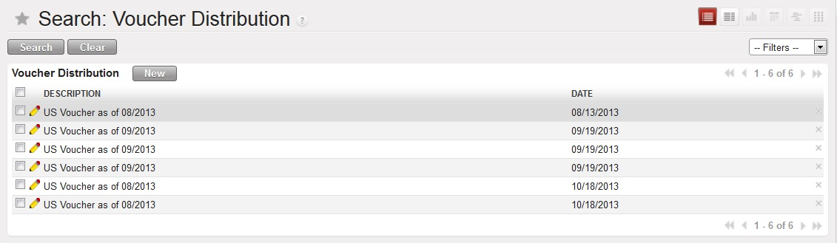

Figure - List View of the Voucher Distribution

* 1. **Form View**

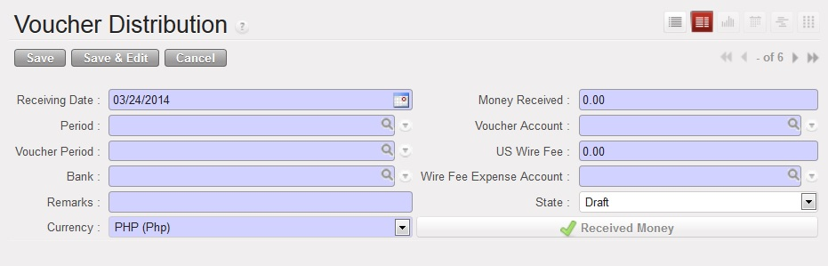

Figure - Initial Form (Receiving Money Transaction)

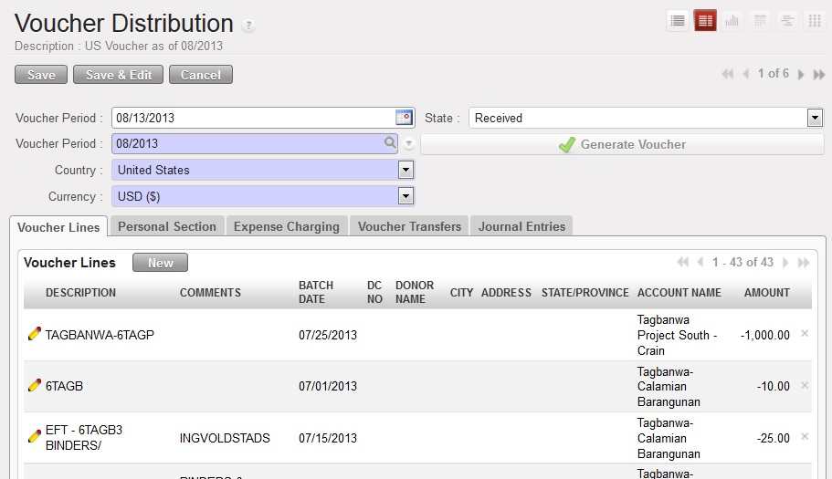

Figure - Voucher Generation

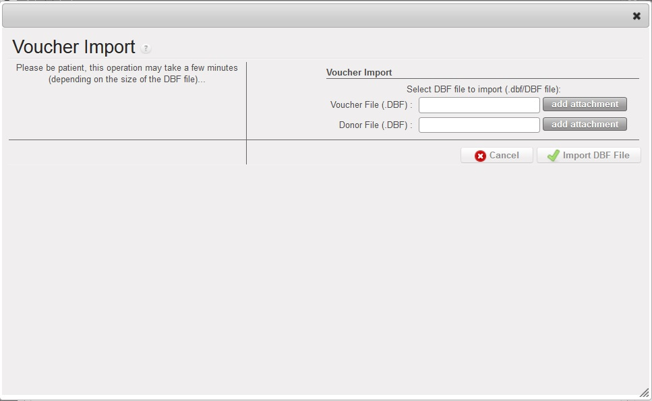

Figure - Voucher and Donor File Upload

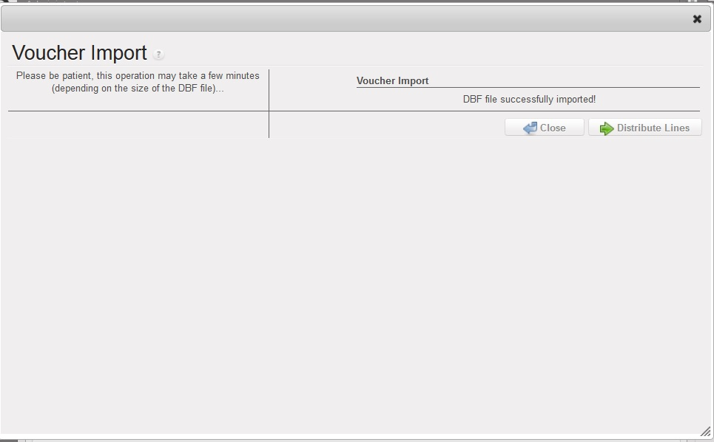

Figure - Distribution of Lines

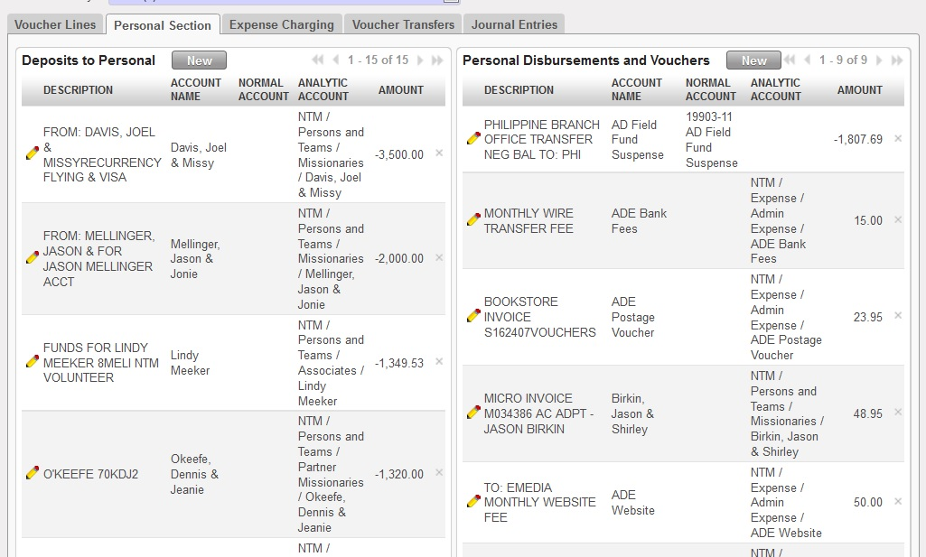

Figure - Personal Section Tab

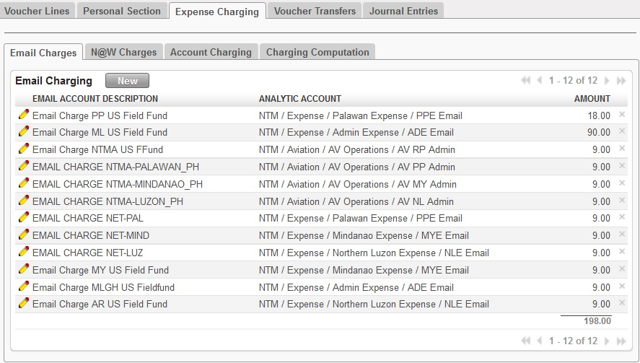

Figure - Expense Charging (Email Charges)

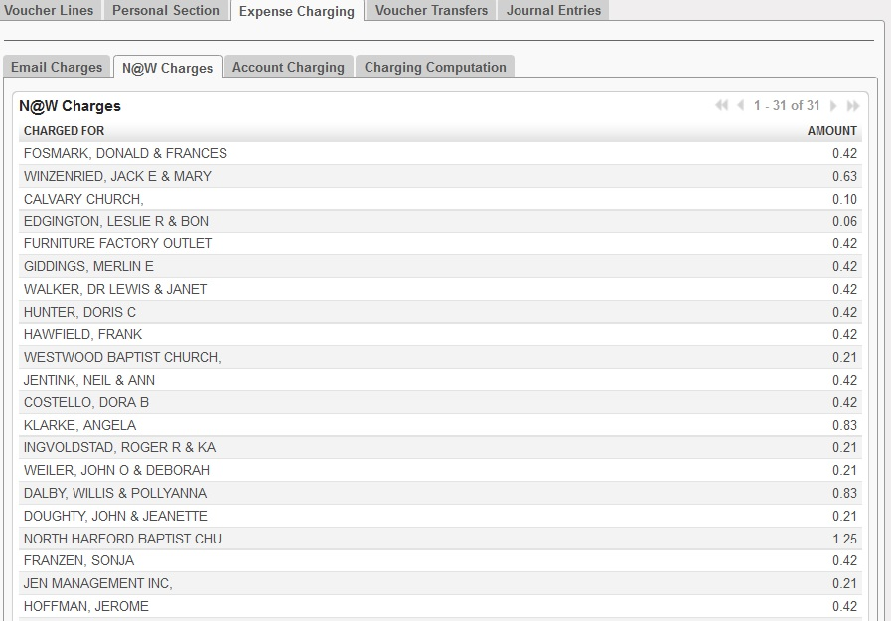

Figure - Expense Charging (N@W Charges)

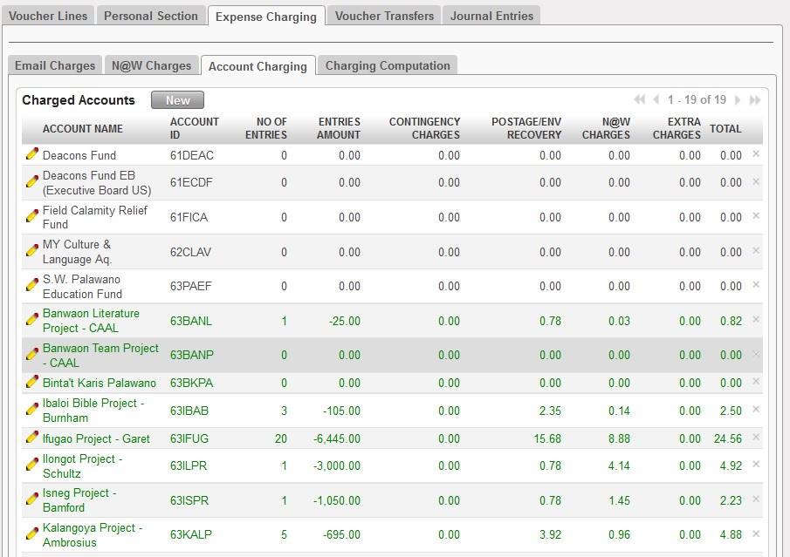

Figure - Expense Charging (Account Charging)

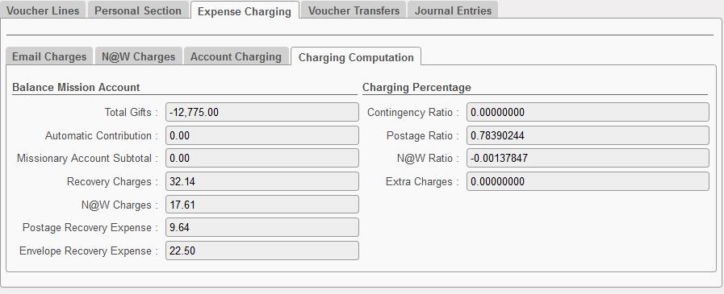

Figure - Expense Charging (Charging Computation)

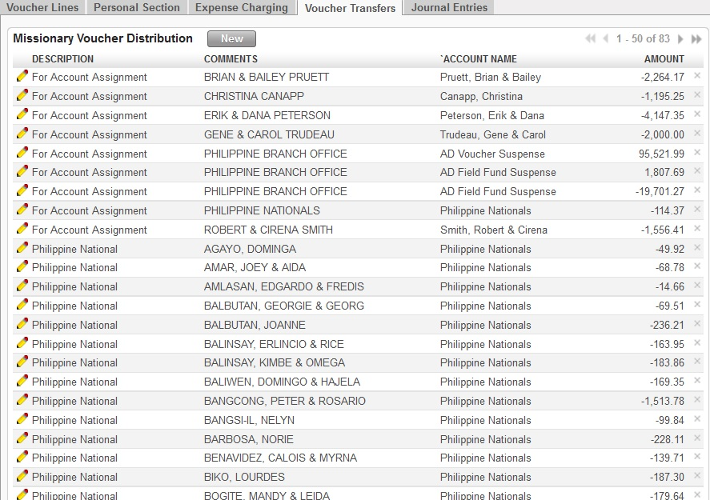

Figure - Voucher Transfers

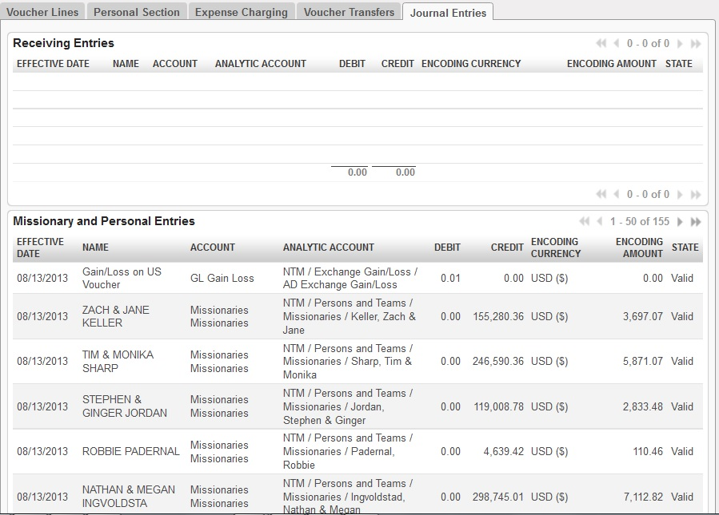

Figure - Journal Entries

1. Menu and Access Right
   1. Menu – People and Projects > *Income Distribution*> *Voucher Distribution*
   2. Access Rights

|  |  |  |  |  |
| --- | --- | --- | --- | --- |
| **Role** | **Read** | **Write** | **Create** | **Delete** |
| **Voucher Distribution Manager** | Yes | Yes | Yes | No |

1. Required Fields (required by State)

|  |  |
| --- | --- |
| **Field Name** | **Required in** |
| **Receiving Date** | Draft |
| **Period** | Draft |
| **Voucher Period** | Draft |
| **Bank** | Draft |
| **Remarks** | Draft |
| **Currency** | Draft |
| **Money Received** | Draft |
| **Voucher Account** | Draft |
| **Wire Fee** | Draft |
| **Wire Fee Expense Account** | Draft |
|  |  |

1. Workflow



Figure Workflow of Income Distribution Process

|  |  |  |
| --- | --- | --- |
| **State** | **Description** | **Visible Buttons** |
| **Draft** | Initial state of the record. User will encode the details of the received money. | **Receive Money** |
| **Received** | Money has been received to the bank. Journal entries for the receiving of money is already created and confirmed. | **Generate Voucher** |
| **Generated** | Record has been reviewed by the Branch manager | **Cancel Distribution Transaction**  **Cancel Transaction** |
| **Distributed** |  |  |
|  |  |  |

1. User Action

|  |  |  |
| --- | --- | --- |
| **Button** | **Action** | **Triggred By** |
| **Receive Money** | Creates journal entries for the receiving part of the transaction. | **Income Distribution Manager** |
| **Cancel Receiving Transaction** | Removes the created JEs for the received money.  Set the state to ‘**Transaction Cancelled**’. | **Income Distribution Manager** |
| **Distribute Donation** | Creates JEs for the distribution part of the transaction. | **Income Distribution Manager** |
| **Cancel Distribution Transaction** | Removes the created JEs for the distribution transaction.  Set the state to ‘**Money Received**’. | **Income Distribution Manager** |
| **Cancel Transaction** | Removes the created JEs for the distribution and receiving transaction.  Set the state to ‘**Transaction Cancelled**’ | **Income Distribution Manager** |

1. Field Visibility

All fields are available for the Income Distribution Manager.

1. Reports and Prints Outs

No Available Reports/Print Outs

1. Errors

|  |  |  |
| --- | --- | --- |
| **ERROR CODE** | **MESSAGE** | **SOLUTION** |
| IDG-001 | *If Charges are still included, bank charges must be greater than 0.00!* | Bank Charges must always be greater than equal to ZERO before clicking the ‘Receive Money’ button when the ‘Charges still included’ checkbox is True. |
| IDG-002 | *You must have a distribution list before distribution!* | Add accounts to where the received money will be distributed. |
| IDG-003 | *Total received amount is not equal to the total amount to be distributed!* | Check the distribution list if the total amount is equal to the amount to be distributed |

## Expense Distribution

### Vehicle Logs

1. Purpose

This records all the trips that a certain vehicle made. This also creates the expenses of the missionaries.

1. Views
   1. **List View**

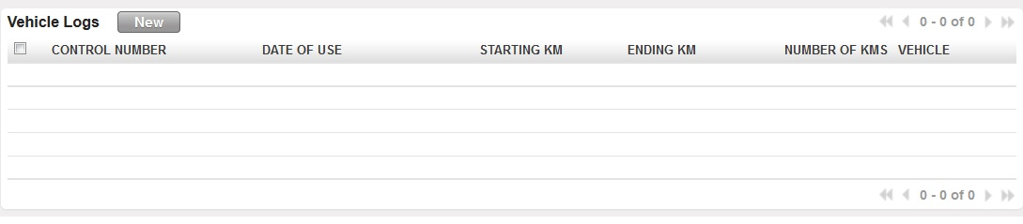

Figure - Vehicle Logs List View

* 1. **Form View**

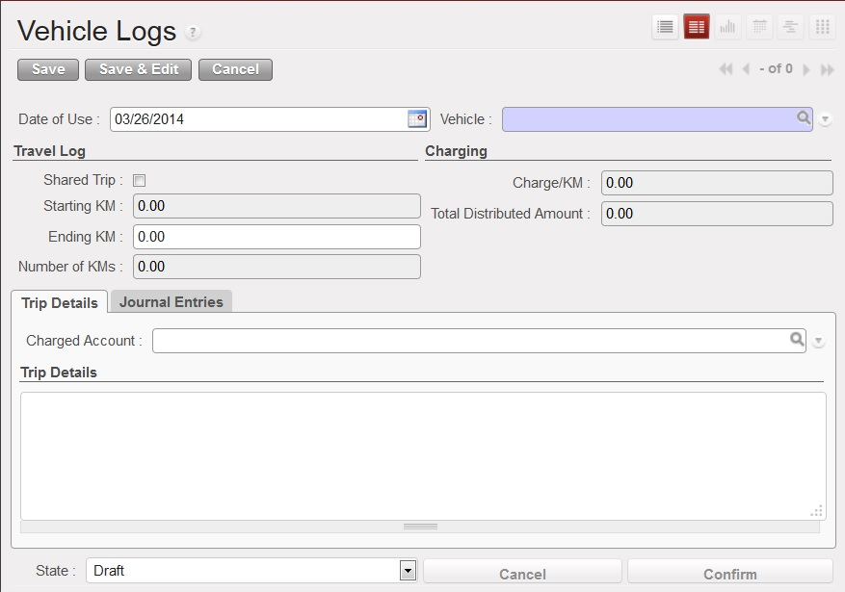

Figure - Form View when shared trip is FALSE

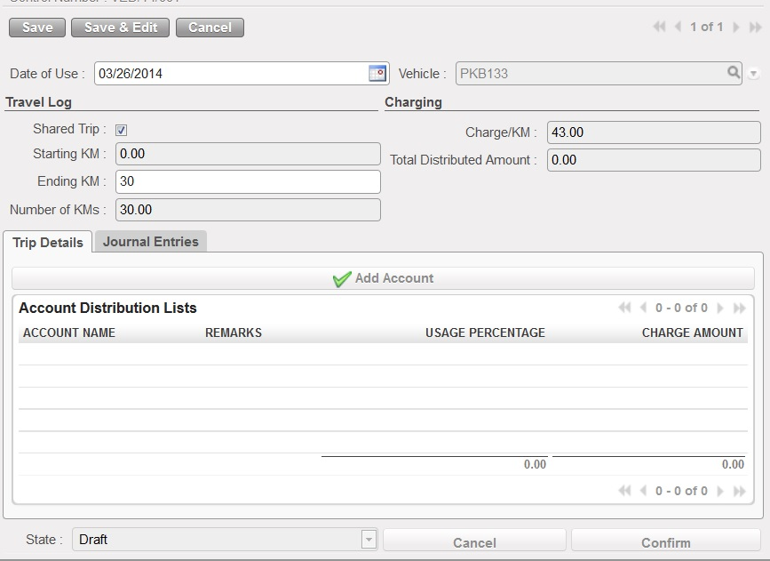

Figure - Form View when shared trip is true

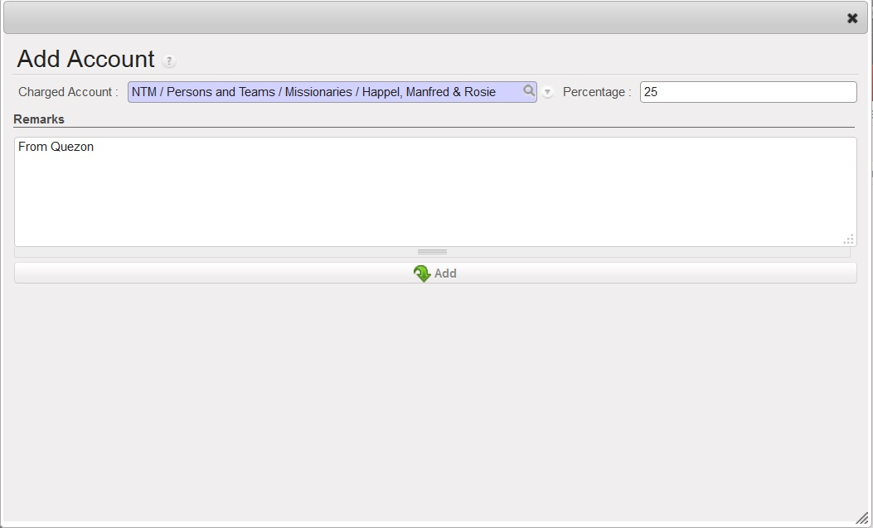

Figure - Add Account Form

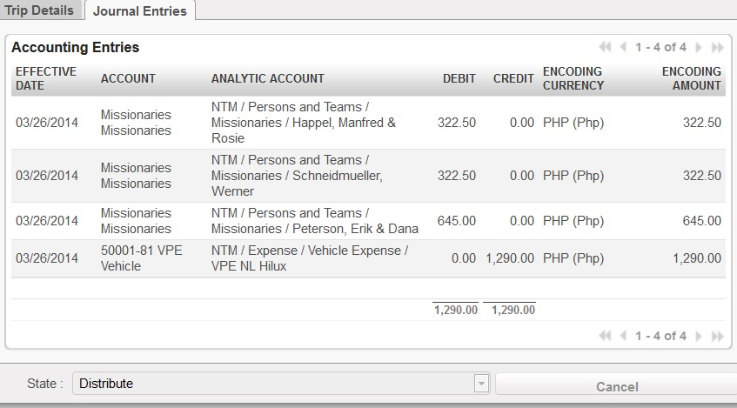

Figure - Journal Entries Tab

1. Menu and Access Right
   1. Menu – People and Projects > *Expense Distribution*> *Vehicle Logs*
   2. Access Rights

|  |  |  |  |  |
| --- | --- | --- | --- | --- |
| **Role** | **Read** | **Write** | **Create** | **Delete** |
| **Vehicle Logger** | Yes | Yes | Yes | No |
| **Vehicle Manager** | Yes | Yes | Yes | Yes |

1. Required Fields (required by State)

|  |  |
| --- | --- |
| **Field Name** | **Required in** |
| **Vehicle ID** | Draft |
| **Charged Account** | Draft |

1. Workflow



Figure - Workflow of Vehicle Logs Procedure

|  |  |  |
| --- | --- | --- |
| **State** | **Description** | **Visible Buttons** |
| **Draft** | Initial state of the record. User will encode the details of the distribution. | **Confirm** |
| **Confirmed** | Changes to the details will be disabled. | **Cancel**  **Distribute** |
| **Distributed** | Journal entries created. | **Cancel** |
| **Cancelled** | On ‘**Cancelled**’ state, all the fields will not be enabled for edit. |  |

1. User Action

|  |  |  |
| --- | --- | --- |
| **Button** | **Action** | **Triggered By** |
| **Confirm** | Disables all fields for editing. | **Vehicle Logger** |
| **Distribute** | Creates the necessary journal entries. | **Vehicle Logger/Vehicle Manager** |
| **Cancel** | Cancel the transaction and removes the created journal entry when state is ‘Distributed’. | **Vehicle Manager** |

1. Field Visibility

All fields are available for the Vehicle Logger/Vehicle Manager.

1. Reports and Prints Outs

No Available Reports/Print Outs

1. Errors

|  |  |  |
| --- | --- | --- |
| **ERROR CODE** | **MESSAGE** | **SOLUTION** |
| ERR-004 | *Negative ending KM is not allowed.* | Ending KM must be greater than the starting KM. |
| ERR-005 | *Percentage of the shared trips is already 100%!* | Adjust percentages to be able to add accounts. |
| ERR-006 | *Shared trip percentage is over by (total_percent - 100)! Adjust your percentage!* | Adjust the percentage of the distribution. |

### Create Statement

1. Purpose

This wizard is used to import the CALLS.DBF file from the phone manager to OpenERP. This would also create the record based on specified user inputs.

1. Views
   1. **Form View**

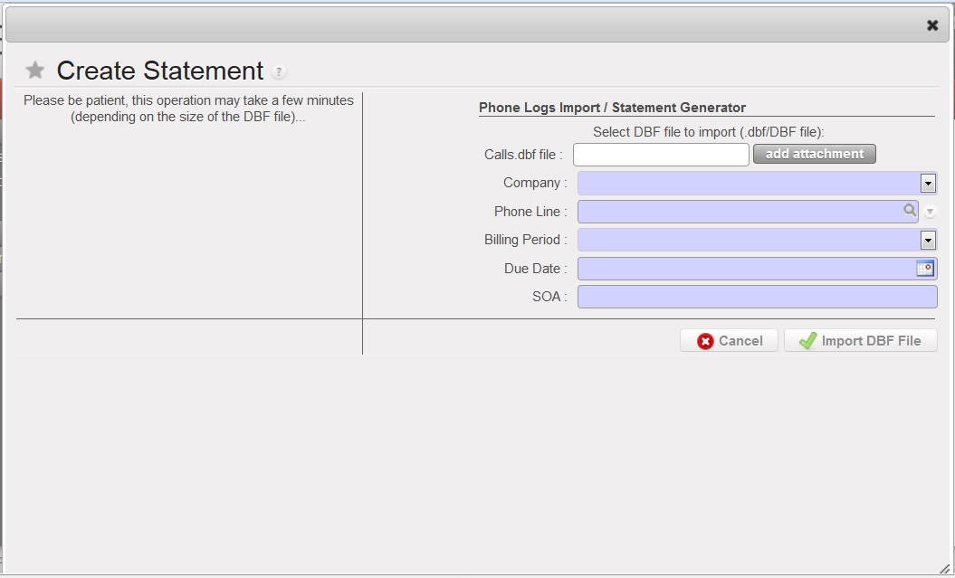

Figure - Import File Form View

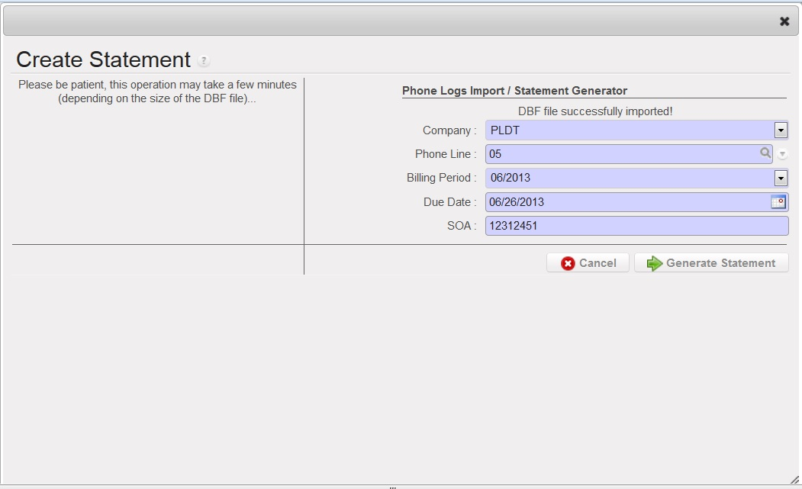

Figure - Generate Statement Form View

1. Menu and Access Right
   1. Menu – People and Projects > *Expense Distribution*> *Create Statement*
   2. Access Rights

|  |  |  |  |  |
| --- | --- | --- | --- | --- |
| **Role** | **Read** | **Write** | **Create** | **Delete** |
| **Phone Log Updater** | Yes | Yes | Yes | No |
| **Phone Manager** | Yes | Yes | Yes | Yes |

1. Required Fields (required by State)

|  |  |
| --- | --- |
| **Field Name** | **Required in** |
| **Vehicle ID** | Draft |
| **Charged Account** | Draft |

|  |  |
| --- | --- |
| **Field Name** | **Required in** |
| **Company** | Draft, Imported |
| **Phone Line** | Draft, Imported |
| **Billing Period** | Draft, Imported |
| **Due Date** | Draft, Imported |
| **SOA** | Draft, Imported |
| **Calls.dbf File** | Draft |

1. Workflow



Figure - Workflow of Create Statement

|  |  |  |
| --- | --- | --- |
| **State** | **Description** | **Visible Buttons** |
| **Import File** | This is the state where the user imports the dbf file. | **Import DBF File, Cancel** |
| **Generate Statement** | This will generate the | **Generate Statement, Cancel** |

1. User Action

|  |  |  |
| --- | --- | --- |
| **Button** | **Action** | **Triggered By** |
| **Import DBF File** | Creates a copy of the imported DBF File. | **Phone Manager** |
| **Generate Statement** | Creates statement of account with data from CALLS.DBF File | **Phone Manager** |
| **Cancel** | Closes the current create statement form. | **Phone Manager** |

1. Field Visibility

All fields are available for the Phone Log Update/Phone Manager

1. Reports and Prints Outs

No Available Reports/Print Outs

1. Errors

|  |  |  |
| --- | --- | --- |
| **ERROR CODE** | **MESSAGE** | **SOLUTION** |
| ERR-007 | *Statement for SOA (SOA_NO) has already been created* | SOA number is unique between statements. |

### Statement of Account

1. Purpose

Statement of Account manages all the created statement of accounts from an imported DBF file. It creates the distribution to accounts and charging entries.

1. Views
   1. **List View**

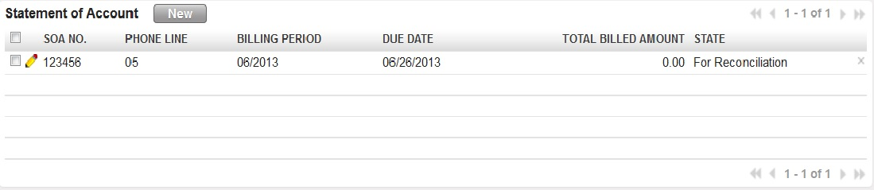

Figure - Statement of Account List

* 1. **Form View**

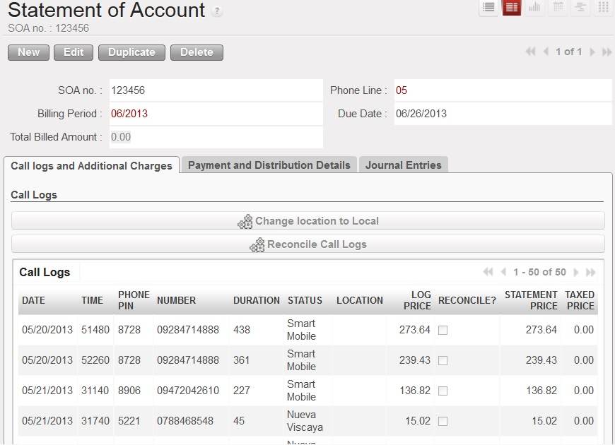

Figure - Main Form

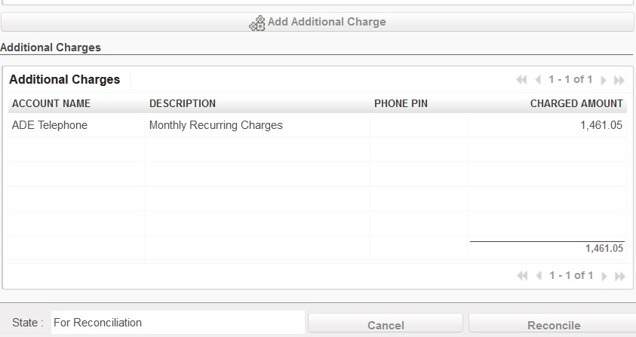

Figure - Additional Charges Lists

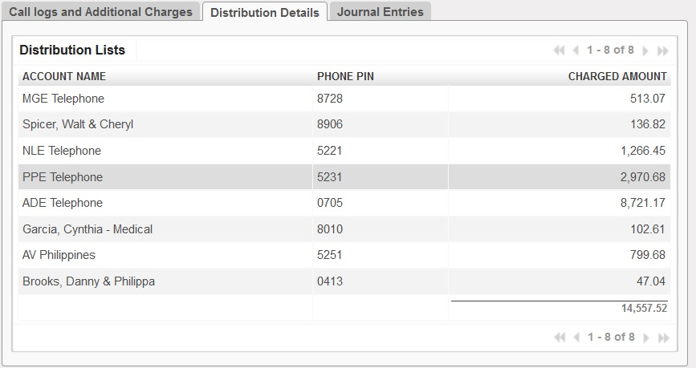

Figure - Distribution Details Tab

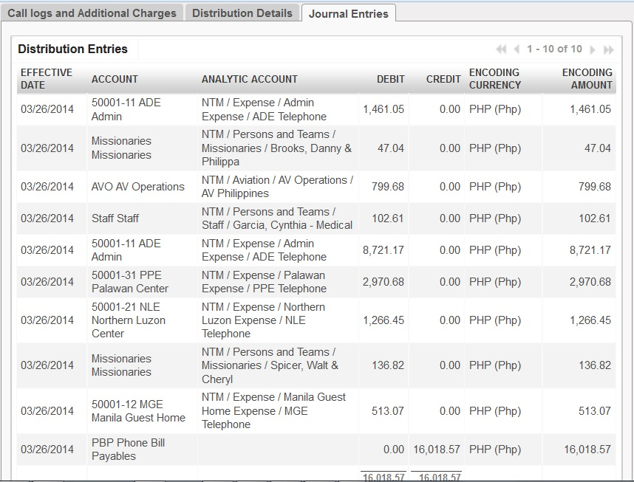

Figure - Journal Entries Tab

1. Menu and Access Right
   1. Menu – People and Projects > *Expense Distribution*> *Statement of Accounts*
   2. Access Rights

|  |  |  |  |  |
| --- | --- | --- | --- | --- |
| **Role** | **Read** | **Write** | **Create** | **Delete** |
| **Phone Log Updater** | Yes | Yes | Yes | No |
| **Phone Manager** | Yes | Yes | Yes | Yes |

1. Required Fields (required by State)

No fields are required since the details came from the Create Statement Procedure.

1. Workflow



Figure - Workflow of Create Statement

|  |  |  |
| --- | --- | --- |
| **State** | **Description** | **Visible Buttons** |
| **Draft** | Initial State. | **Reconcile, Cancel** |
| **Reconciled** | In this state, the call logs have been distributed to specific accounts. | **Distribute, Cancel** |
| **Distributed** | In this state, the journal entries had been created. | **Cancel** |
| **Cancelled** | In this state, the created journal entries are deleted. |  |

1. User Action

|  |  |  |
| --- | --- | --- |
| **Button** | **Action** | **Triggered By** |
| **Change Location to Local** | Change the location field of all logs to ‘**Local**’ | **Phone Manager** |
| **Reconcile Call Logs** | Creates statement of account with data from CALLS.DBF File | **Phone Manager** |
| **Add Additional Account** | Closes the current create statement form. | **Phone Manager** |
| **Reconcile** | Sets the state to ‘**Reconciled**’. | **Phone Manager** |
| **Distribute** | Sets the state to ‘**Distributed**’.  Distributes the call logs to specific phone pins/account ready for charging. **Phone Manager** | **Phone Manager** |
| **Charge Phone Expenses** | Sets the state to ‘**Charged**’.  Creates the journal entries for the charged accounts. | **Phone Manager** |

1. Field Visibility

All fields are available for the Phone Manager.

1. Reports and Prints Outs

No Available Reports/Print Outs

1. Errors

|  |  |  |
| --- | --- | --- |
| **ERROR CODE** | **MESSAGE** | **SOLUTION** |
| ERR-008 | *Please change the location!* | Change the location of all the international calls. For local calls, click the change location to local button |
| ERR-009 | *All call logs must be reconciled first before reconciling the statement!* | Click the Reconcile Call Logs button to compute for the taxed price per call log. |
| ERR-010 | *Please check the reconciliation! Total amount of call logs and additional charges is not equal to billed amount.* | Change the value of the Total Billed Amount field to the sum of call logs taxed price and the additional charges. |
| ERR-011 | *Pin # is not yet configured. Please create this phone pin on the Phone Pin Configuration.* | Create the Phone Pin to the list of phone pines. |
| ERR-012 | *No account connected to the phone pin.* | Check the configuration of the phone pin. |

### Other Expenses

1. Purpose

This procedure records all the other expenses that is being paid using checks.

1. Views
   1. **List View**

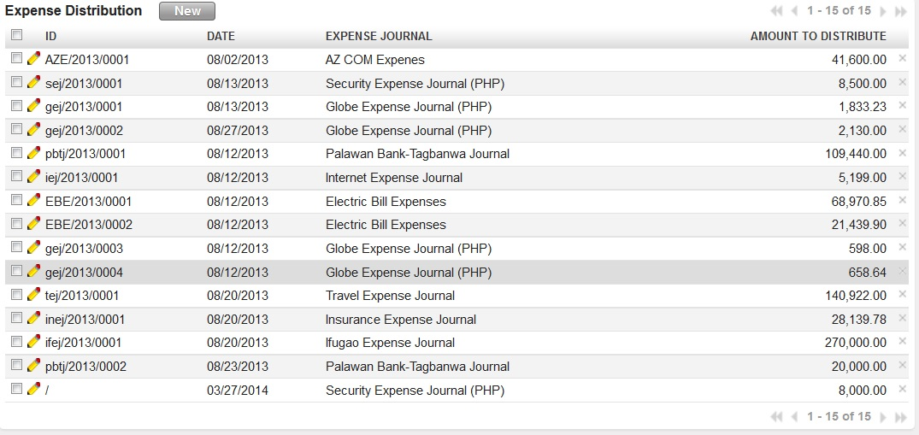

Figure - Other Expenses List

* 1. **Form View**

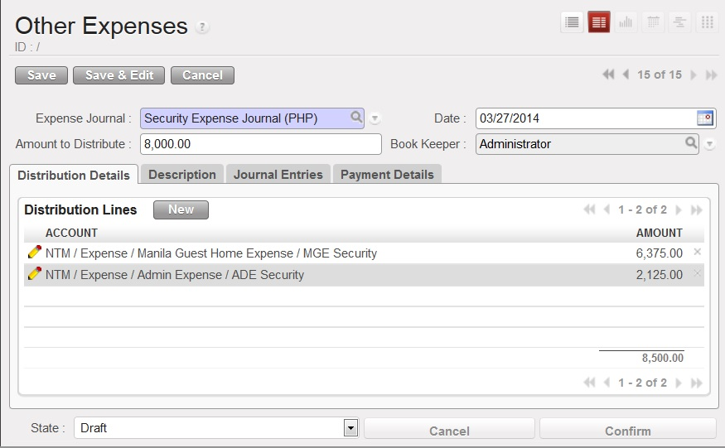

Figure – Other Expenses (Distribution Details/Initial Form)

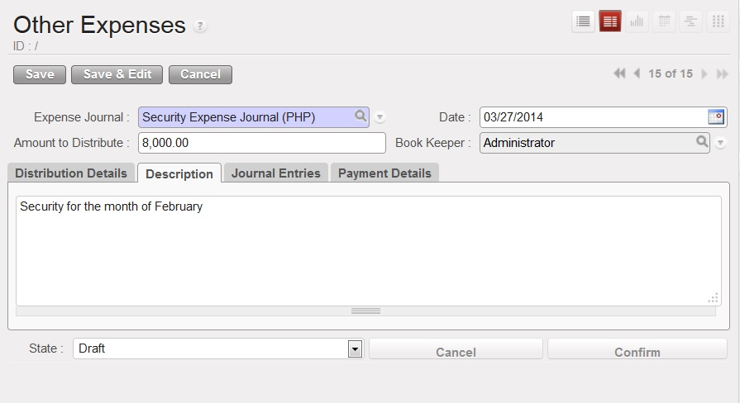

Figure - Expense Description Tab

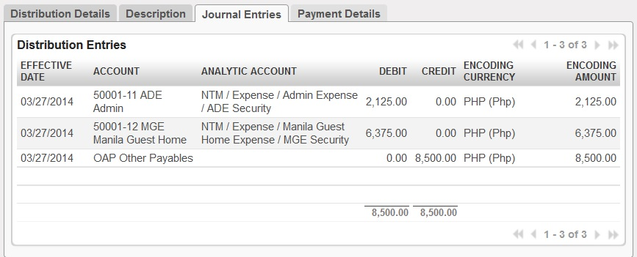

Figure - Journal Entries Tab

1. Menu and Access Right
   1. Menu – People and Projects > *Expense Distribution*> *Other Expenses*
   2. Access Rights

|  |  |  |  |  |
| --- | --- | --- | --- | --- |
| **Role** | **Read** | **Write** | **Create** | **Delete** |
| **Expense Manager** | Yes | Yes | Yes | No |

1. Required Fields (required by State)

|  |  |
| --- | --- |
| **Field Name** | **Required in** |
| **Expense Journal** | Draft |

1. Workflow



Figure - Workflow of Other Expenses

|  |  |  |
| --- | --- | --- |
| **State** | **Description** | **Visible Buttons** |
| **Draft** | Initial state of the record. In this state, the user encodes the necessary details of the expense distribution. | **Confirm** |
| **Confirmed** | In this state, the details are disabled for modification. | **Distribute, Cancel** |
| **Distributed** | The journal entries for the distribution have been created. | **Cancel** |
| **Cancelled** | No modifications are allowed to the record. If the following state prior to cancellation is distributed, the journal entries will be deleted. |  |

1. User Action

|  |  |  |
| --- | --- | --- |
| **Button** | **Action** | **Triggered By** |
| **Confirm** | Sets the state to ‘**Confirmed**’ state.  Disables all the field for modification. | **Expense Manager** |
| **Distribute** | Creates the journal entries based on the distribution lists. | **Expense Manager** |
| **Cancel** | If the state prior to cancellation is in ‘**Distributed**’, the created journal entries will be deleted.  Sets the state to ‘**Cancelled**’ | **Expense Manager** |

1. Field Visibility

All fields are available for the Expense Manager

1. Reports and Prints Outs

No Available Reports/Print Outs

1. Errors

|  |  |  |
| --- | --- | --- |
| **ERROR CODE** | **MESSAGE** | **SOLUTION** |
| ERR-013 | *Zero expense amounts are not allowed.* | Change the amount to distribute to the total amount of distribution lines. |
| ERR-014 | *Zero charged amount is not allowed.* | Change the amounts of the distribution line where the amount is ZERO. |
| ERR-015 | *Expense amount is not equal to distribution line amount total.* | Change the amount to distribute to the total amount of distribution lines. |

### Direct Bank Expenses

1. Purpose

This procedure records all expenses that are directly deducted from banks.

1. Views
   1. **List View**

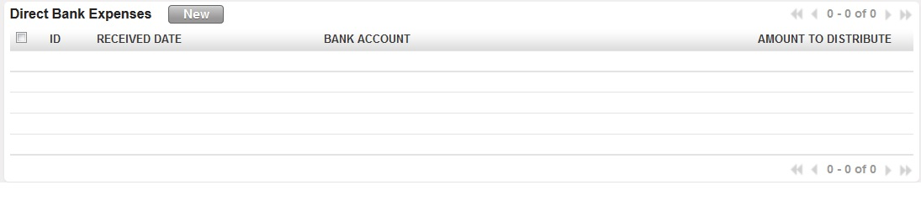

Figure - Direct Bank Expense List View

* 1. **Form View**

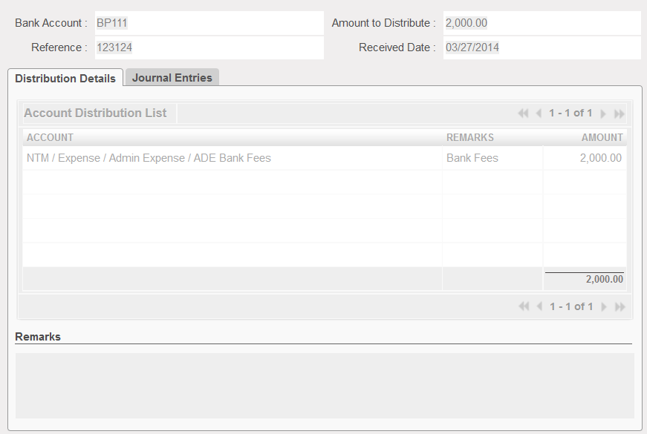

Figure - Initial Form with Distribution Details Tab

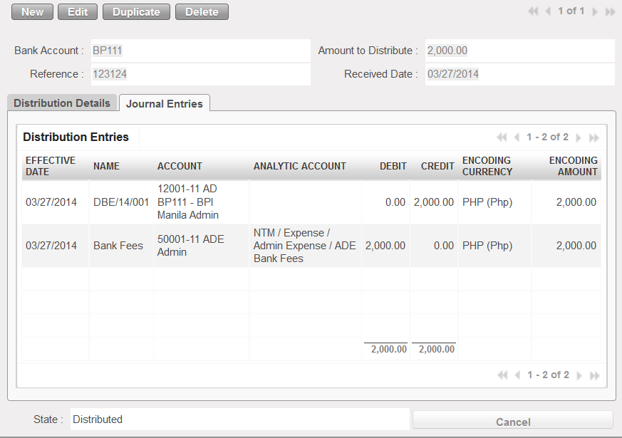

Figure - Journal Entries Tab (Direct Bank Expense)

1. Menu and Access Right
   1. Menu – People and Projects > *Expense Distribution*>*Direct Bank Expenses*
   2. Access Rights

|  |  |  |  |  |
| --- | --- | --- | --- | --- |
| **Role** | **Read** | **Write** | **Create** | **Delete** |
| **Expense Manager** | Yes | Yes | Yes | No |

1. Required Fields (required by State)

|  |  |
| --- | --- |
| **Field Name** | **Required in** |
| **Bank Account** | Draft |
| **Reference** | Draft |
| **Amount to Distribute** | Draft |
| **Received Date** | Draft |

1. Workflow



Figure - Workflow of Direct Bank Expense

|  |  |  |
| --- | --- | --- |
| **State** | **Description** | **Visible Buttons** |
| **Draft** | Initial state of the record. | **Distribute** |
| **Distributed** | Journal Entries created. | **Cancel** |

1. User Action

|  |  |  |
| --- | --- | --- |
| **Button** | **Action** | **Triggered By** |
| **Distribute** | Creates journal entries based on distribution lists. | **Expense Manager** |
| **Cancel** | Cancels the record and deletes the created journal entries. | **Expense Manager** |

1. Field Visibility

Only the DBE # field is not available on the form view.

1. Reports and Prints Outs

No Available Reports/Print Outs

1. Errors

|  |  |  |
| --- | --- | --- |
| **ERROR CODE** | **MESSAGE** | **SOLUTION** |
| ERR-016 | *Total received amount is not equal to the total amount to be distributed.* | Check all amounts. |

## Configuration

### Vehicles

1. Purpose

This is where the Vehicle Manager adds the vehicles that will be available for selection on the Vehicle Logs.

1. Views
   1. **List View**

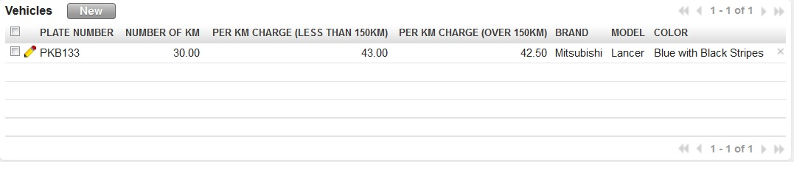

Figure - Vehicles List

* 1. **Form View**

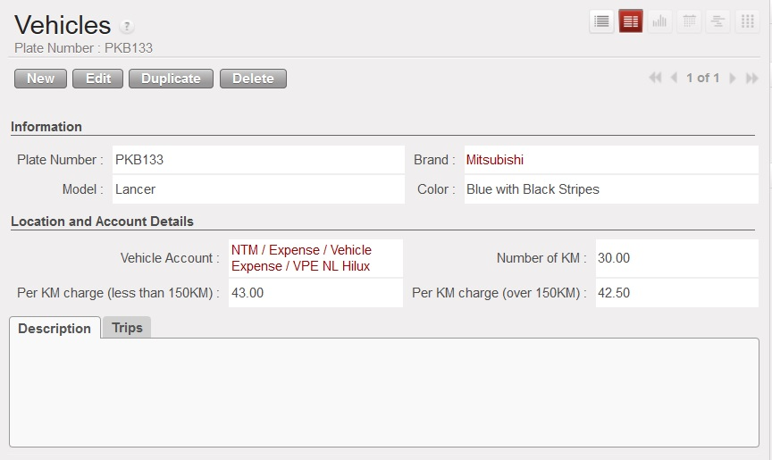

Figure - Vehicles Initial Form with Description Tab

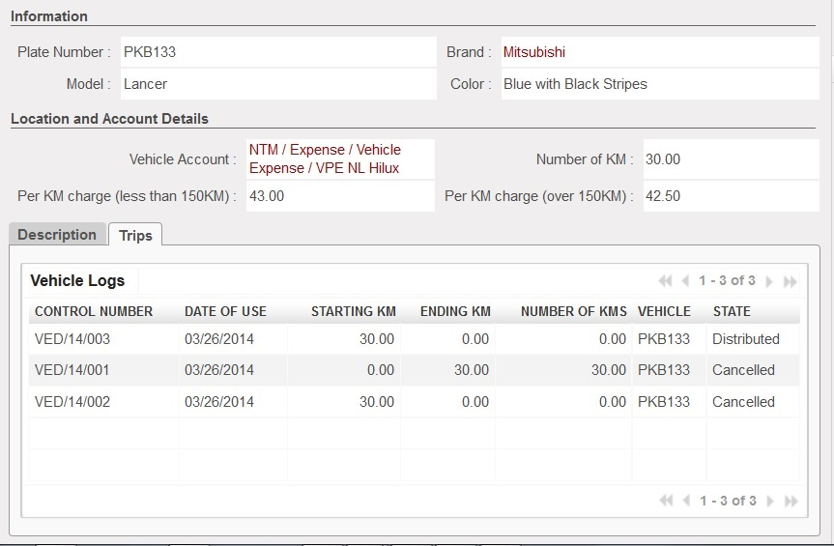

Figure - Vehicle Form with Trips Listing

1. Menu and Access Right
   1. Menu – People and Projects > *Configuration*> *Vehicle Manager*
   2. Access Rights

|  |  |  |  |  |
| --- | --- | --- | --- | --- |
| **Role** | **Read** | **Write** | **Create** | **Delete** |
| **Vehicle Manager** | Yes | Yes | Yes | No |

1. Required Fields (required by State)

|  |
| --- |
| **Field Name** |
| **Plate Number** |
| **Brand** |
| **Model** |
| **Color** |
| **Vehicle Account** |

1. Workflow

No Available Workflow for Vehicle Configuration

1. User Action

No available user action for Vehicle Configuration

1. Field Visibility

All fields are available for the Vehicle Manager.

1. Reports and Prints Outs

No Available Reports/Print Outs

1. Errors

No Available Errors

### Phone Lines

1. Purpose

This is used to configure the phone lines that are referred to by the **Create Statement**and **Statement of Account** procedures.

1. Views
   1. **List View**

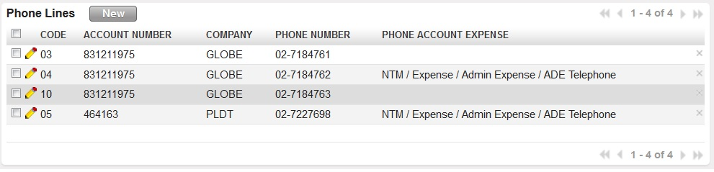

Figure - Phone Lines List View

* 1. **Form View**

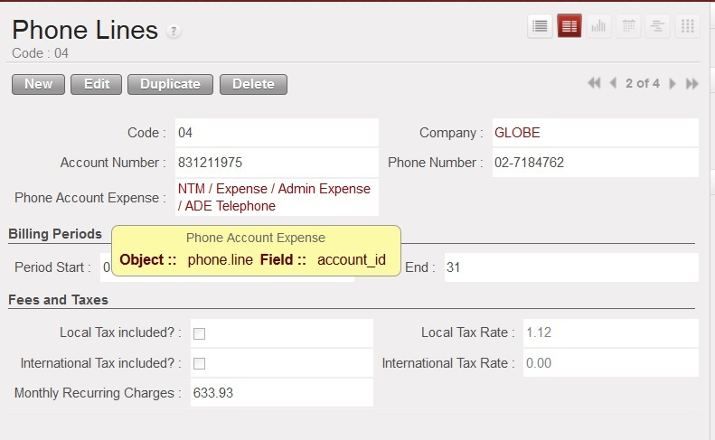

Figure - Phone Lines Form View

1. Menu and Access Right
   1. Menu – People and Projects > *Configuration*> *Phone Lines*
   2. Access Rights

|  |  |  |  |  |
| --- | --- | --- | --- | --- |
| **Role** | **Read** | **Write** | **Create** | **Delete** |
| **Phone Manager** | Yes | Yes | Yes | Yes |

1. Required Fields (required by State)

|  |  |
| --- | --- |
| **Field Name** | **Required in** |
| **Code** | Required by default |
| **Company** | Required by default |
| **Account Number** | Required by default |
| **Phone Number** | Required by default |
| **Phone Account Expense** | Required by default |
| **Local Tax Rate** | Required when local tax included checkbox is **TRUE** |
| **International Tax Rate** | Required when international tax included checkbox is **TRUE** |

1. Workflow

No Available Workflow for Vehicle Configuration

1. User Action

No available user action for Vehicle Configuration

1. Field Visibility

All fields are available for the Vehicle Manager.

1. Reports and Prints Outs

No Available Reports/Print Outs

1. Errors

No Available Errors

### Phone Pins

1. Purpose

This is used to configure the phone pins that are referred on the distribute user action of **Statement of Account**.

1. Views
   1. **List View**

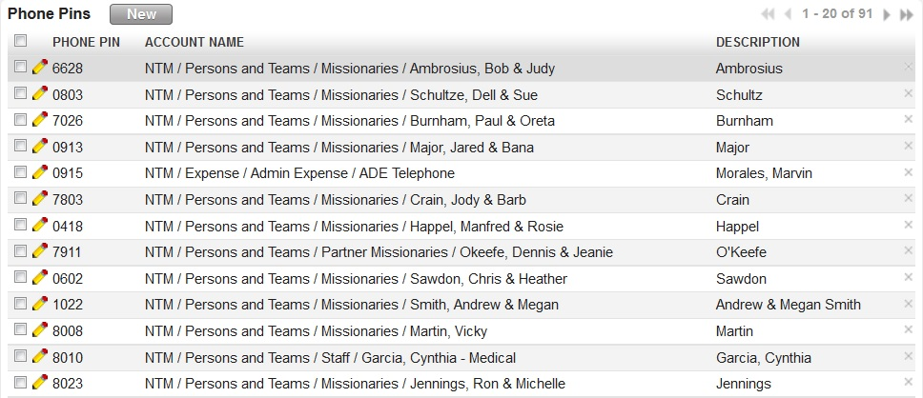

Figure - Phone Pin Configuration List View

* 1. **Form View**

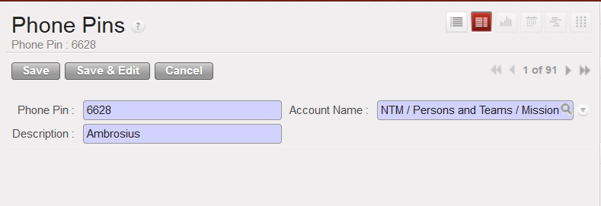

1. Menu and Access Right
   1. Menu – People and Projects > *Configuration*> *Phone Pins*
   2. Access Rights

|  |  |  |  |  |
| --- | --- | --- | --- | --- |
| **Role** | **Read** | **Write** | **Create** | **Delete** |
| **Phone Manager** | Yes | Yes | Yes | Yes |

1. Required Fields (required by State)

|  |
| --- |
| **Field Name** |
| **Phone Pin** |
| **Account Name** |
| **Description** |

1. Workflow

No Available Workflow for Vehicle Configuration

1. User Action

No available user action for Vehicle Configuration

1. Field Visibility

All fields are available for the Vehicle Manager.

1. Reports and Prints Outs

No Available Reports/Print Outs

1. Errors

No Available Errors

### Voucher Configurations

#### Email Charging Accounts

1. Purpose

This is used for the configuration of email accounts that are referred to the **Voucher Distribution** procedure.

1. Views
   1. **List View**

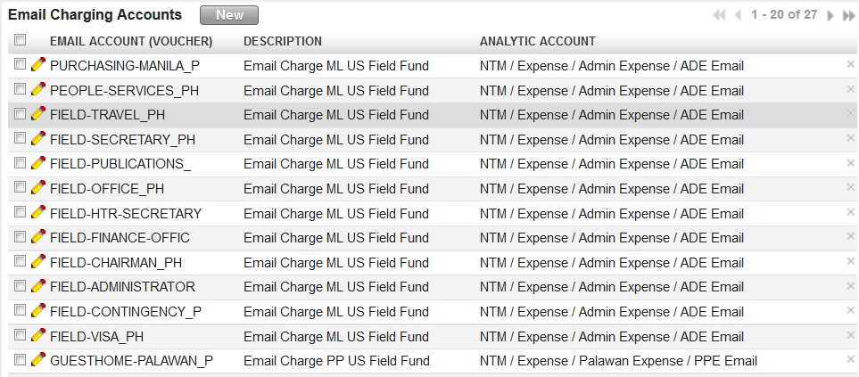

Figure – Email Charging Accounts Configuration List

* 1. **Form View**

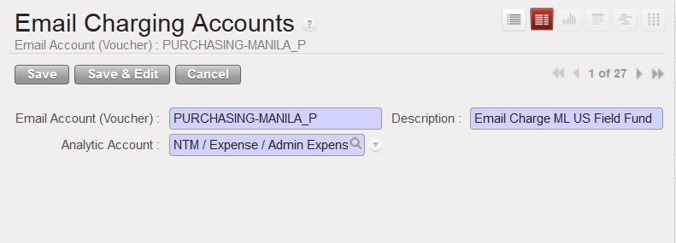

Figure - Email Charging Accounts Configuration Form

1. Menu and Access Right
   1. Menu – People and Projects > *Configuration >* *Voucher Configurations > Email Charging Accounts*
   2. Access Rights

|  |  |  |  |  |
| --- | --- | --- | --- | --- |
| **Role** | **Read** | **Write** | **Create** | **Delete** |
| **Voucher Manager** | Yes | Yes | Yes | Yes |

1. Required Fields (required by State)

|  |  |
| --- | --- |
| **Field Name** | **Required in** |
| **Email Account (Voucher)** | Creation |
| **Description** | Creation |
| **Analytic Account** | Creation |

1. Workflow

No Available Workflow for Vehicle Configuration

1. User Action

No available user action for Vehicle Configuration

1. Field Visibility

All fields are available for the Vehicle Manager.

1. Reports and Prints Outs

No Available Reports/Print Outs

1. Errors

No Available Errors

#### Missionary Account Distribution Reference

1. Purpose

This is used for the configuration of missionary accounts that are referred to the **Voucher Distribution** procedure.

1. Views
   1. **List View**

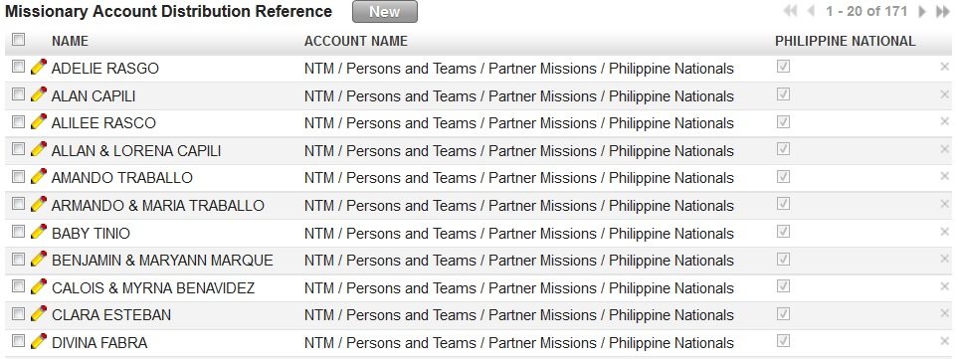

Figure 53 – Missionary Account Distribution Reference Lists

* 1. **Form View**

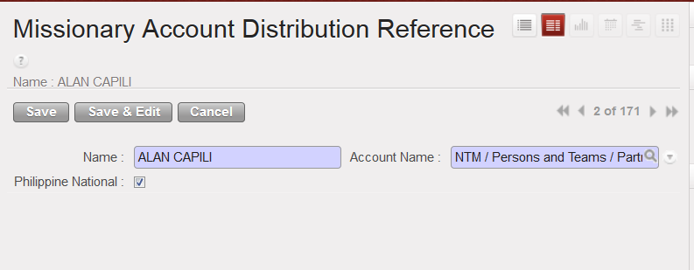

Figure 54 - Missionary Account Distribution Reference Form

1. Menu and Access Right
   1. Menu – People and Projects > *Configuration >* *Voucher Configurations > Missionary Account Distribution Reference*
   2. Access Rights

|  |  |  |  |  |
| --- | --- | --- | --- | --- |
| **Role** | **Read** | **Write** | **Create** | **Delete** |
| **Voucher Manager** | Yes | Yes | Yes | Yes |

1. Required Fields (required by State)

|  |  |
| --- | --- |
| **Field Name** | **Required in** |
| **Name** | Creation |
| **Account Name** | Creation |

1. Workflow

No Available Workflow for Vehicle Configuration

1. User Action

No available user action for Vehicle Configuration

1. Field Visibility

All fields are available for the Vehicle Manager.

1. Reports and Prints Outs

No Available Reports/Print Outs

1. Errors

No Available Errors

#### Project Account Distribution Reference

1. Purpose

This is used for the configuration of project accounts that are referred to the **Voucher Distribution** procedure.

1. Views
   1. **List View**
   2. **Form View**
2. Menu and Access Right
   1. Menu – People and Projects > *Configuration >* *Telecommunications Companies*
   2. Access Rights

|  |  |  |  |  |
| --- | --- | --- | --- | --- |
| **Role** | **Read** | **Write** | **Create** | **Delete** |
| **Voucher Manager** | Yes | Yes | Yes | Yes |

1. Required Fields (required by State)

|  |  |
| --- | --- |
| **Field Name** | **Required in** |
| **Company** | Creation |

1. Workflow

No Available Workflow for Vehicle Configuration

1. User Action

No available user action for Vehicle Configuration

1. Field Visibility

All fields are available for the Vehicle Manager.

1. Reports and Prints Outs

No Available Reports/Print Outs

1. Errors

No Available Errors

# Bank and Cash

## Bank Accounts

## Bank Reconciliation

### Check Clearing

1. Purpose

This is where the check is reconciled for clearing at the actual date of withdrawal of the Payee.

1. Views
   1. **List View**

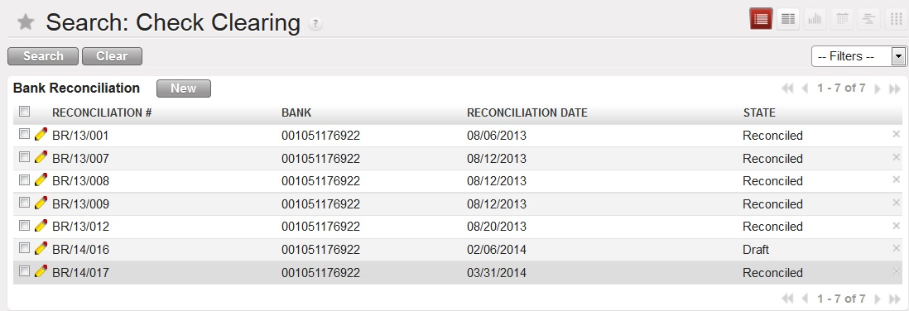

* 1. **Form View**

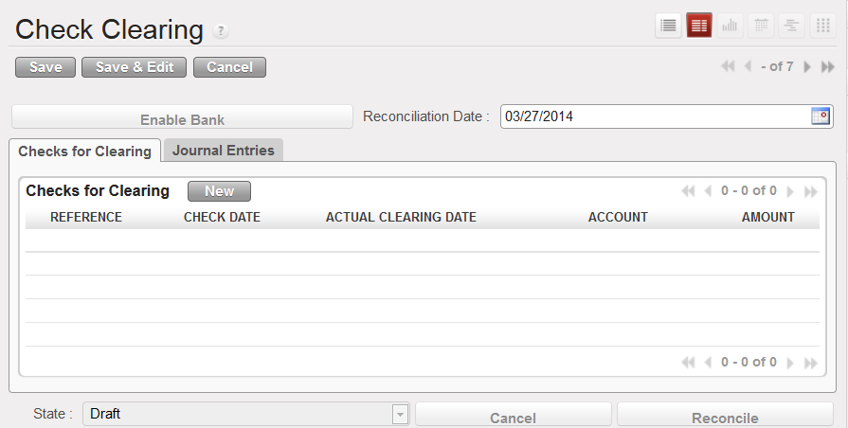

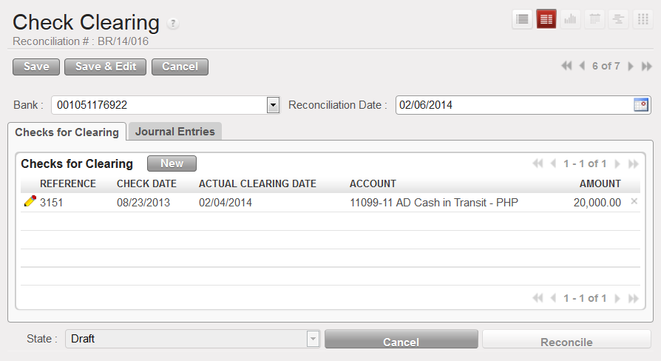

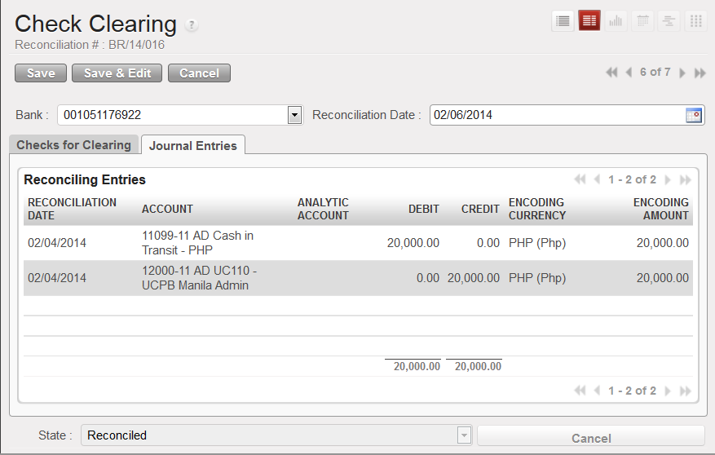

1. Menu and Access Right
   1. Menu – Bank and Cash> *Bank Reconciliation >Check Clearing*
   2. Access Rights

|  |  |  |  |  |
| --- | --- | --- | --- | --- |
| **Role** | **Read** | **Write** | **Create** | **Delete** |
| **Bank Reconciliation Manager** | Yes | Yes | Yes | No |

1. Required Fields (required by State)

|  |  |
| --- | --- |
| **Field Name** | **Required in** |
| **Reconciliation Date** | Draft |

1. Workflow



|  |  |  |
| --- | --- | --- |
| **State** | **Description** | **Visible Buttons** |
| **Draft** | Initial state of the record. User will encode the details of the received money. | **Reconcile** |
| **Reconciled** | In this state, the journal entries have been created and sets the state of the check | **Cancel** |
| **Cancelled** | In this state, no modifications will be allowed. The related journal entries are also deleted |  |

1. User Action

|  |  |  |
| --- | --- | --- |
| **Button** | **Action** | **Triggred By** |
| **Enable Bank** | Saves the record to enable the bank account selection. | **Bank Reconciliation Manager** |
| **Reconcile** | Create journal entries for the deduction on the book bank account and sets the state of the record to ‘**Reconciled**’. | **Bank Reconciliation Manager** |
| **Cancel** | Removes the created journal entries upon reconciliation and sets the state of the record to ‘**Cancelled**’. | **Bank Reconciliation Manager** |

1. Field Visibility

All fields are available for the Bank Reconciliation Manager.

1. Reports and Prints Outs

No Available Reports/Print Outs

1. Errors

No Available Error Codes

### Fund Transfer Clearing

1. Purpose

This is where the bank transfers that are not yet cleared is being processed for deduction on the book bank account.

1. Views
   1. **List View**

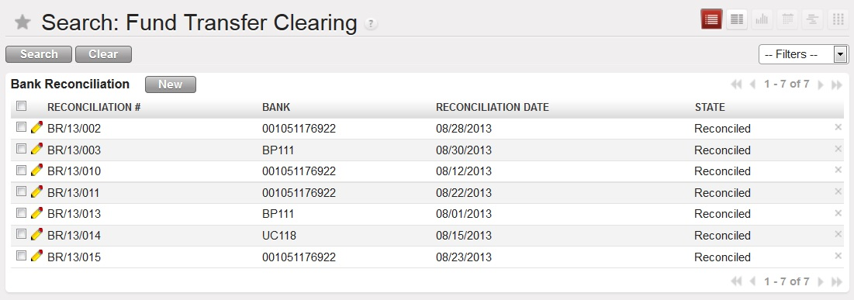

* 1. **Form View**

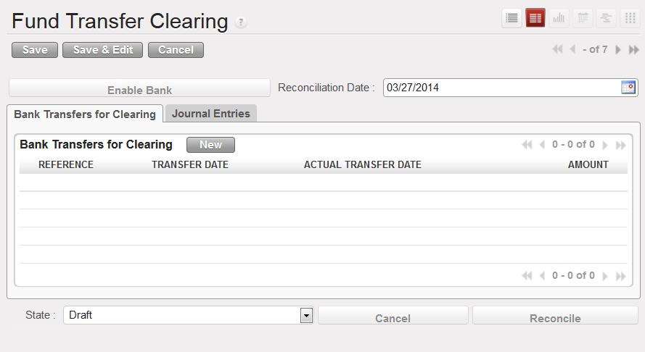

1. Menu and Access Right
   1. Menu – Bank and Cash> *Bank Reconciliation >Check Clearing*
   2. Access Rights

|  |  |  |  |  |
| --- | --- | --- | --- | --- |
| **Role** | **Read** | **Write** | **Create** | **Delete** |
| **Bank Reconciliation Manager** | Yes | Yes | Yes | No |

1. Required Fields (required by State)

|  |  |
| --- | --- |
| **Field Name** | **Required in** |
| **Reconciliation Date** | Draft |

1. Workflow



|  |  |  |
| --- | --- | --- |
| **State** | **Description** | **Visible Buttons** |
| **Draft** | Initial state of the record. User will encode the details of the received money. | **Reconcile** |
| **Reconciled** | In this state, the journal entries have been created and sets the state of the check | **Cancel** |
| **Cancelled** | In this state, no modifications will be allowed. The related journal entries are also deleted |  |

1. User Action

|  |  |  |
| --- | --- | --- |
| **Button** | **Action** | **Triggred By** |
| **Enable Bank** | Saves the record to enable the bank account selection. | **Bank Reconciliation Manager** |
| **Reconcile** | Create journal entries for the deduction on the book bank account and sets the state of the record to ‘**Reconciled**’. | **Bank Reconciliation Manager** |
| **Cancel** | Removes the created journal entries upon reconciliation and sets the state of the record to ‘**Cancelled**’. | **Bank Reconciliation Manager** |

1. Field Visibility

All fields are available for the Bank Reconciliation Manager.

1. Reports and Prints Outs

No Available Reports/Print Outs

1. Errors

No Available Error Codes

## Petty Cash

### Monitoring

1. Purpose

This is where the check is reconciled for clearing at the actual date of withdrawal of the Payee.

1. Views
   1. **List View**

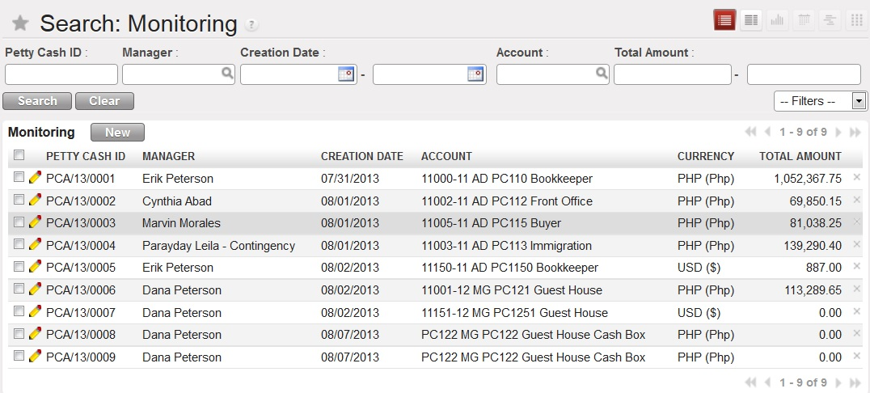

* 1. **Form View**

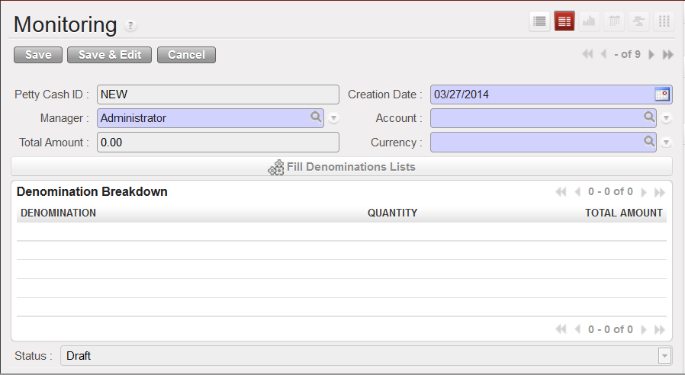

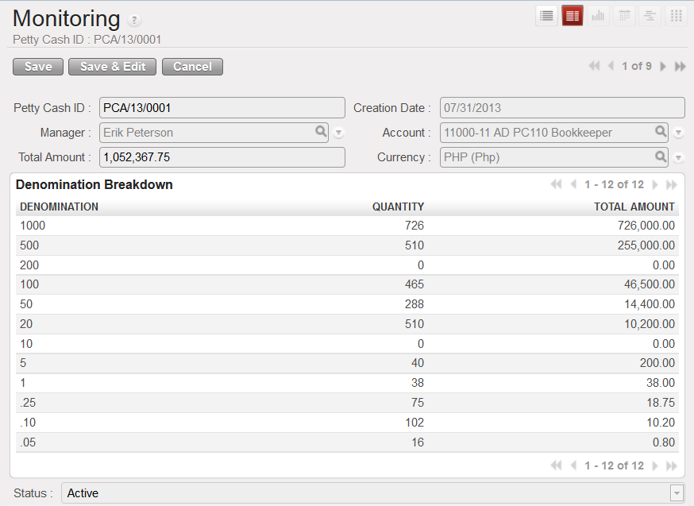

1. Menu and Access Right
   1. Menu – Bank and Cash> *Petty Cash>Monitoring*
   2. Access Rights

|  |  |  |  |  |
| --- | --- | --- | --- | --- |
| **Role** | **Read** | **Write** | **Create** | **Delete** |
| **Petty Cash Administrator** | Yes | Yes | No | No |
| **Petty Cash Manager** | Yes | Yes | Yes | No |

1. Required Fields (required by State)

|  |  |
| --- | --- |
| **Field Name** | **Required in** |
| **Creation Date** | Draft |
| **Manager** | Draft |
| **Account** | Draft |
| **Currency** | Draft |

1. Workflow



|  |  |  |
| --- | --- | --- |
| **State** | **Description** | **Visible Buttons** |
| **Draft** | Initial state of the record. Petty Cash Manager needs to fill the required fields. | **Fill Denomination Lists** |
| **Active** | In this state, the fields are disabled for modification |  |

1. User Action

|  |  |  |
| --- | --- | --- |
| **Button** | **Action** | **Triggred By** |
| **Fill Denomination LIsts** | Creates the denomination lists. | **Petty Cash Manager** |

1. Field Visibility

All fields are available for the Petty Cash Manager

1. Reports and Prints Outs

No Available Reports/Print Outs

1. Errors

|  |  |  |
| --- | --- | --- |
| **ERROR CODE** | **MESSAGE** | **SOLUTION** |
| PCM-001 | *Please define the petty cash account.* | Link the petty cash account to a normal account. |

### Bills Exchange

1. Purpose

This is where the check is reconciled for clearing at the actual date of withdrawal of the Payee.

1. Views
   1. **List View**

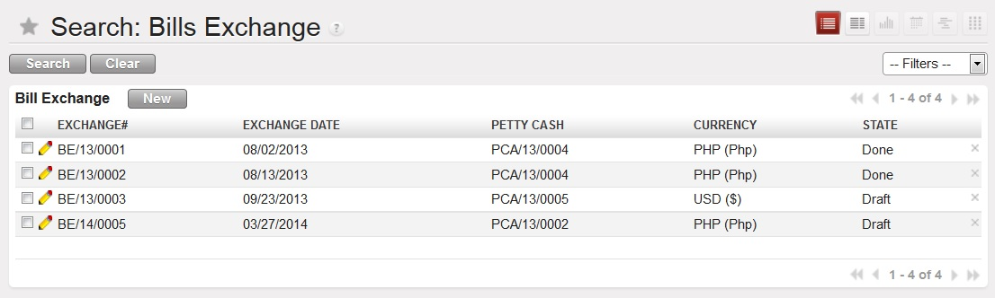

* 1. **Form View**

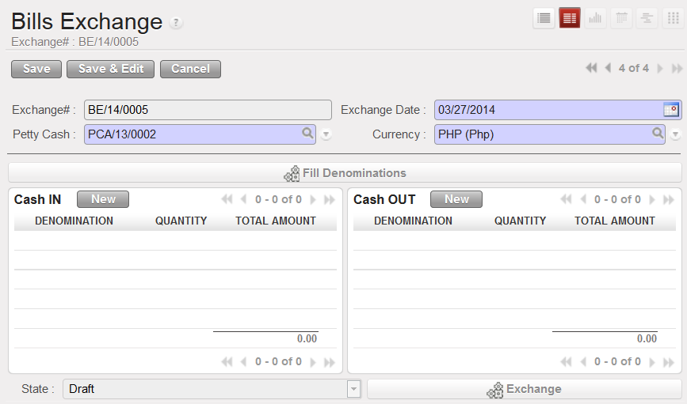

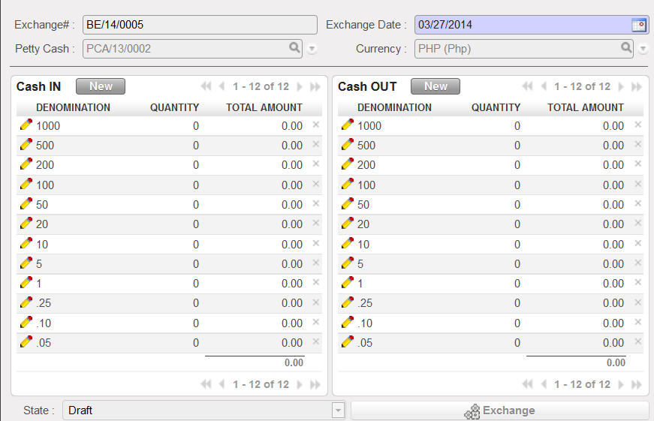

1. Menu and Access Right
   1. Menu – Bank and Cash> *Petty Cash>Bills Exchange*
   2. Access Rights

|  |  |  |  |  |
| --- | --- | --- | --- | --- |
| **Role** | **Read** | **Write** | **Create** | **Delete** |
| **Petty Cash Administrator** | Yes | Yes | Yes | No |
| **Petty Cash Manager** | Yes | Yes | Yes | No |

1. Required Fields (required by State)

|  |  |
| --- | --- |
| **Field Name** | **Required in** |
| **Exchange Date** | Draft |
| **Petty Cash** | Draft |
| **Currency** | Draft |

1. Workflow



|  |  |  |
| --- | --- | --- |
| **State** | **Description** | **Visible Buttons** |
| **Draft** | Initial state of the record. Petty Cash Manager needs to fill the required fields. He also needs to change the quantity of the cash in denomination and cash out denomination | **Fill Denomination Lists**  **Exchange** |
| **Done** | In this state, the fields are disabled for modification. |  |

1. User Action

|  |  |  |
| --- | --- | --- |
| **Button** | **Action** | **Triggred By** |
| **Fill Denomination LIsts** | Creates the denomination lists. | **Petty Cash Manager** |

1. Field Visibility

All fields are available for the Petty Cash Manager

1. Reports and Prints Outs

No Available Reports/Print Outs

1. Errors

|  |  |  |
| --- | --- | --- |
| **ERROR CODE** | **MESSAGE** | **SOLUTION** |
| BE-001 | *<Currency> has no available denominations. Please add them* | Add denominations for the currency via Denominations. |
| BE-002 | *Please indicate the quantities of the denominations to be exchanged.* | Indicate the quantity of the denomination to be exchanged. |
| BE-003 | *Please indicate the quantities of the denominations to be released.* | Indicate the quantity of the denomination to be released. |
| BE-004 | *Total amounts are not equal.* | Check the Cash in and Cash Out tables |
| BE-005 | *Quantity to be release is greater than the cash on petty cash for denomination <denom>.* | Change the quantity of the denomination involved. |

### Replenishment

1. Purpose

Records all the petty cash replenishment transactions.

1. Views
   1. **List View**

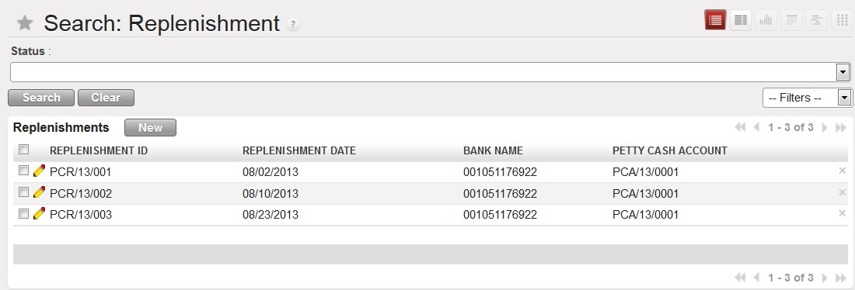

* 1. **Form View**

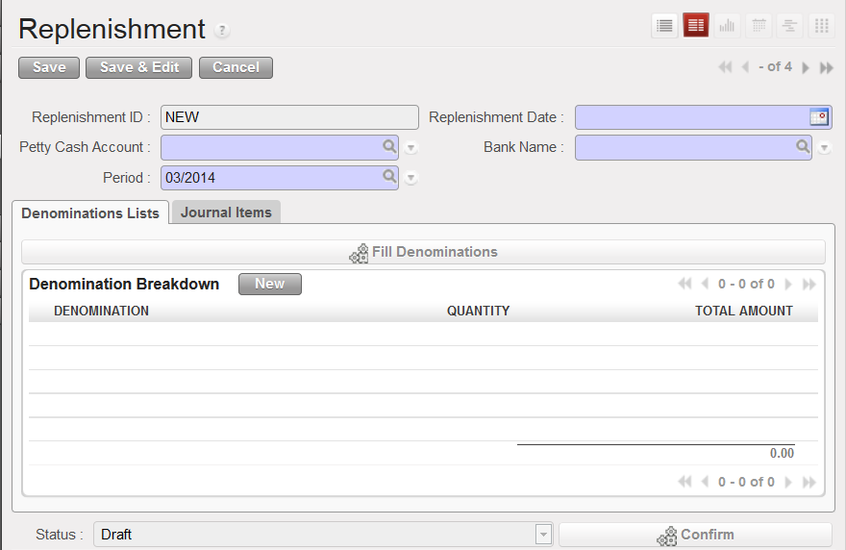

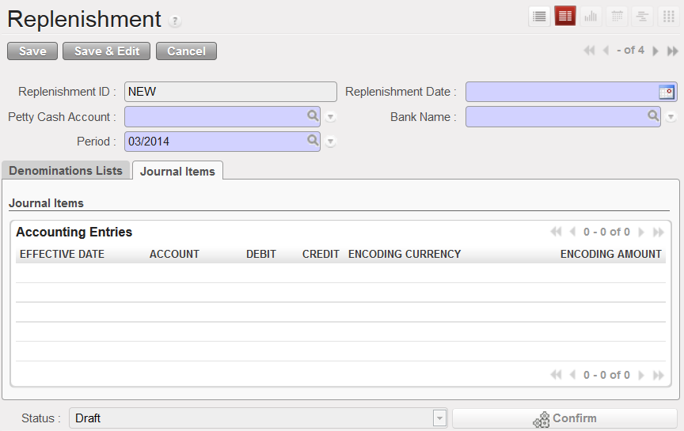

1. Menu and Access Right
   1. Menu – Bank and Cash> *Petty Cash>Replenishment*
   2. Access Rights

|  |  |  |  |  |
| --- | --- | --- | --- | --- |
| **Role** | **Read** | **Write** | **Create** | **Delete** |
| **Petty Cash Manager** | Yes | Yes | Yes | No |

1. Required Fields (required by State)

|  |  |
| --- | --- |
| **Field Name** | **Required in** |
| **Replenishment Date** | Draft |
| **Petty Cash Account** | Draft |
| **Bank Name** | Draft |
| **Period** | Draft |

1. Workflow



|  |  |  |
| --- | --- | --- |
| **State** | **Description** | **Visible Buttons** |
| **Draft** | Initial state of the record. Petty Cash Manager needs to fill the required fields. He also needs to change the quantity of the denomination to be replenished. | **Fill Denomination Lists**  **Confirm** |
| **Confirmed** | In this state, the fields are disabled for modification. | **Cancel** |
| **Completed** | Journal entries had been created. | **Cancel** |
| **Cancelled** | No modifications allowed. |  |

1. User Action

|  |  |  |
| --- | --- | --- |
| **Button** | **Action** | **Triggered By** |
| **Fill Denomination Lists** | Updates the denominations lists based on the currency of the petty cash account. | **Petty Cash Manager** |
| **Confirm** | Verifies the quantity of the denomination to be replenished. Also, it checks if the bank balance is greater than the replenished amount.  Sets the state to ‘**Confirmed**’. | **Petty Cash Manager** |
| **Complete** | Creates the necessary journal entries.  Set the state to ‘**Completed**’ | **Petty Cash Manager** |
| **Cancel** | Removes the created journal entries.  Set the state to ‘**Cancelled**’ | **Petty Cash Manager** |

1. Field Visibility

All fields are available for the Petty Cash Manager

1. Reports and Prints Outs

No Available Reports/Print Outs

1. Errors

|  |  |  |
| --- | --- | --- |
| **ERROR CODE** | **MESSAGE** | **SOLUTION** |
| ERR-022 | *Replenishments with amount less than or equal to ZERO are not allowed.* | Check for the quantity of the denomination to be replenished. |
| ERR-023 | *Insufficient Funds! Please check you bank balance.* | Update first the balance of the bank where to get the fund before confirming the transaction. |
| ERR-024 | *<Currency> has no available denominations. Please add them!* | Create the denominations for the currency. |

### Daily Transactions

1. Purpose

Records the daily transactions created by Petty Cash managers.

1. Views
   1. **List View**

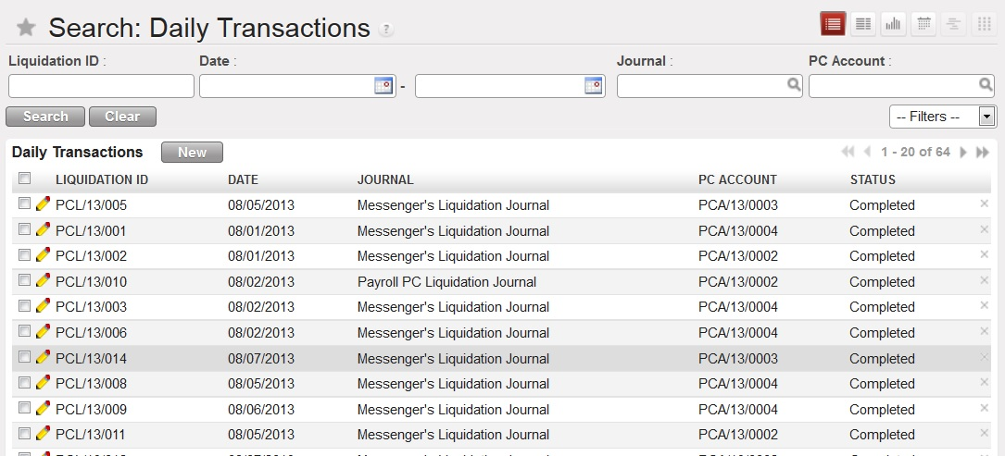

* 1. **Form View**

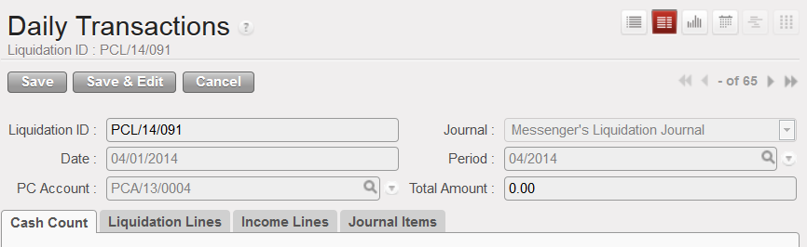

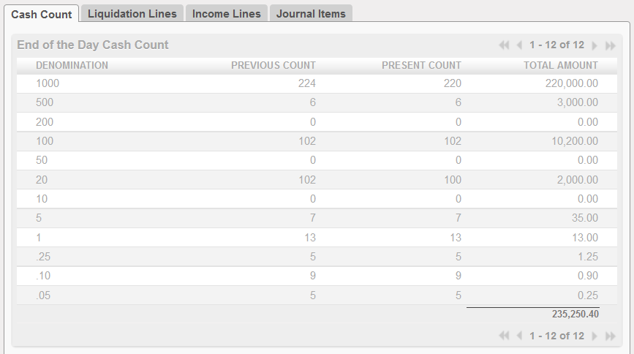

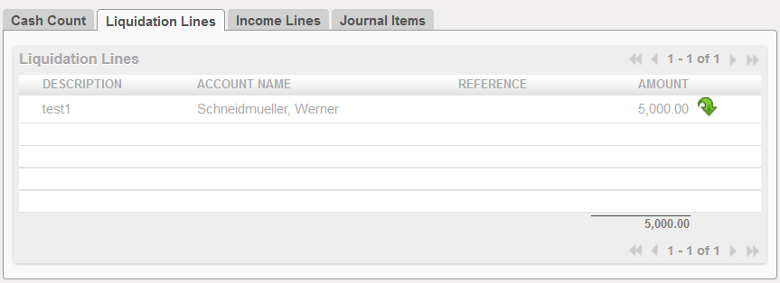

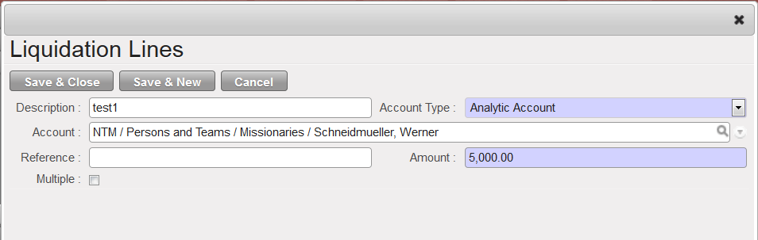

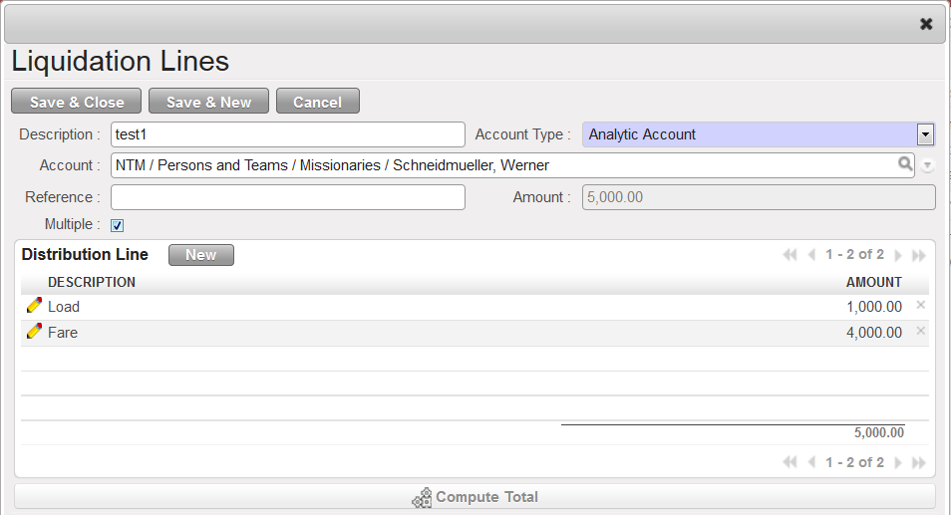

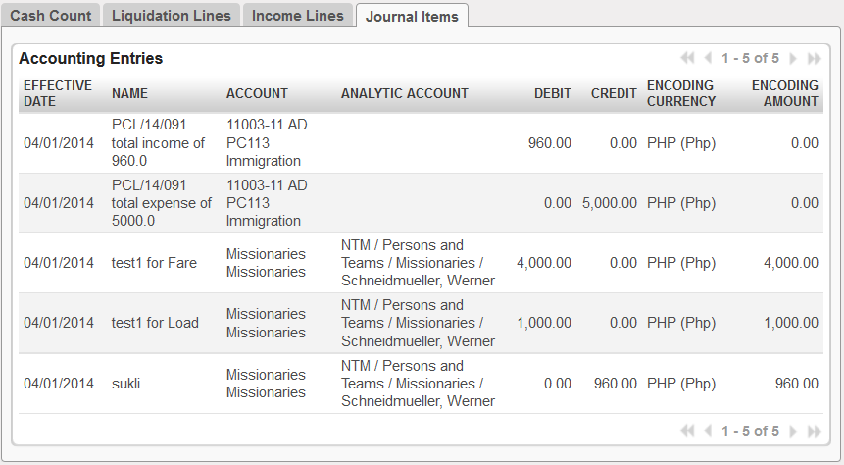

1. Menu and Access Right
   1. Menu – Bank and Cash> *Petty Cash>P/C to P/C Transfer*
   2. Access Rights

|  |  |  |  |  |
| --- | --- | --- | --- | --- |
| **Role** | **Read** | **Write** | **Create** | **Delete** |
| **Petty Cash Administrator** | Yes | Yes | Yes | No |
| **Petty Cash Manager** | Yes | Yes | Yes | No |

1. Required Fields (required by State)

|  |  |
| --- | --- |
| **Field Name** | **Required in** |
| **Date** | Draft |
| **Journal** | Draft |
| **Period** | Draft |
| **PC Account** | Draft |

1. Workflow



|  |  |  |
| --- | --- | --- |
| **State** | **Description** | **Visible Buttons** |
| **Draft** | Initial state of the document. | **Confirm** |
| **Confirmed** | In this state, the total amount of liquidation lines and income lines has been checked based on the amount of money deducted/added to the petty cash. | **Release**  **Cancel** |
| **Completed** | In this state, the journal entries for the charging of liquidation lines and income lines have been generated. The quantity of the denominations has been updated. | **Cancel** |
| **Cancelled** | The created entries for the charging were removed and the quantity of the denominations has been reverted to the previous count. | **Set to Draft** |

1. User Action

|  |  |  |
| --- | --- | --- |
| **Button** | **Action** | **Triggered By** |
| **Fill Denomination Lists** | Updates the denominations lists based on the currency of the petty cash account. | **Petty Cash Manager** |
| **Confirm** | Checks the liquidation lines less the income lines if equal to the amount deducted from the previous count of the denominations. | **Petty Cash Manager** |
| **Complete** | Creates the journal entries for the charging of liquidation and income lines. | **Petty Cash Manager** |
| **Cancel** | Removal of journal entry when the state is complete.  Change state to ‘**Cancel**’. | **Petty Cash Manager** |
| **Set to Draft** | Sets the state to ‘**Draft**’. | **Petty Cash Manager** |

1. Field Visibility

All fields are available for the Petty Cash Manager

1. Reports and Prints Outs
2. Errors

|  |  |  |
| --- | --- | --- |
| **ERROR CODE** | **MESSAGE** | **SOLUTION** |
| ERR-025 | *Source and destination petty cash accounts have different currencies.* | Check the source and destination accounts. |
| ERR-026 | *Change the quantity of the denomination to transfer.* | Check for the quantity of the denomination to be transferred. |
| ERR-027 | *Quantity of the source denomination is less than the requested quantity.* | Check the quantity of the denomination to be transferred from the source petty cash. |
| ERR-028 | *You are not <user>! Only <User> can release/receive cash for this drawer!* | The user to process should be the manager of the petty cash. |
| ERR-029 | *Change the quantity of the denomination to receive!* | Check for the quantity of the denomination to be received. |
| ERR-030 | *Total amounts are not equal!* | Check the quantity of the denomination to be received. |

## **Fund** **Transfers**

### Bank Transfers

#### Unscheduled

#### Scheduled

#### All Requests

#### Generate Transfer Requests

### Internal Bank Transfers

1. Purpose

This process is used for transferring funds from one company owned bank account to another company owned bank account. It records all the transfers and keeps the fund transfers entries for the book bank accounts reconciled based on the actual release and receive dates.

1. Views
   1. **List View**

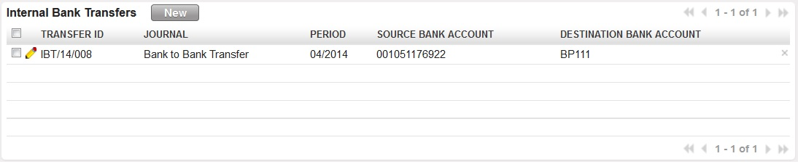

* 1. **Form View**

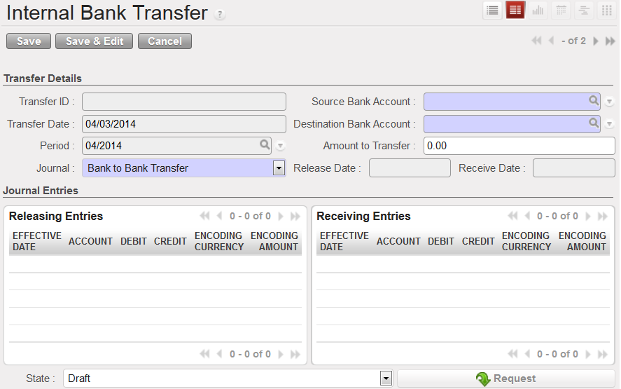

1. Menu and Access Right
   1. Menu – Bank and Cash> *Fund Transfers > Internal Bank Transfers*
   2. Access Rights

|  |  |  |  |  |
| --- | --- | --- | --- | --- |
| **Role** | **Read** | **Write** | **Create** | **Delete** |
| **Internal Bank Manager** | Yes | Yes | Yes | No |

1. Required Fields (required by State)

|  |  |
| --- | --- |
| **Field Name** | **Required in** |
| **Transaction Date** | Draft |
| **Source Petty Cash** | Draft |
| **Destination Petty Cash** | Draft |

1. Workflow



|  |  |  |
| --- | --- | --- |
| **State** | **Description** | **Visible Buttons** |
| **Draft** | Initial state of the document. | **Send Request**  **Cancel** |
| **Requested** | The balance of the source bank account has been checked if it has funds to be able to release the desired amount. | **Release from Bank**  **Cancel** |
| **Released** | Journal entries for releasing the money from the bank are already created. | **Receive to Bank**  **Cancel** |
| **Transferred** | Journal entries for receiving the money to the destination bank are already created. | **Cancel** |
| **Cancelled** | No modifications will be made, cancellation of entries based on previous state. |  |

1. User Action

|  |  |  |
| --- | --- | --- |
| **Button** | **Action** | **Triggered By** |
| **Send Requests** | Checks the balance of the source bank account for funds. | **Internal Bank Manager** |
| **Print** | Prints a pdf file print out of the request. | **Internal Bank Manager** |
| **Release from Bank** | Creation of releasing journal entries.  Change state to ‘**Released**’. | **Internal Bank Manager** |
| **Receive to Bank** | Creation of receiving journal entries.  Change state to ‘**Received**. | **Internal Bank Manager** |
| **Cancel** | Removal of journal entry based on previous state.  Change state to ‘**Cancel**’. | **Internal Bank Manager** |

1. Field Visibility

All fields are available for the **Internal Bank Manager.**

1. Reports and Prints Outs

No Available Reports/Print Outs

1. Errors

|  |  |  |
| --- | --- | --- |
| **ERROR CODE** | **MESSAGE** | **SOLUTION** |
| IBT-001 | *Source and destination are the same!* | Change either source or destination bank account. |
| IBT-002 | *Amount less than or equal to ZERO is not allowed!* | Change the amount to desired amount to transfer. |

### Petty Cash to Petty Cash

1. Purpose

This procedure records all the petty cash transfers.

1. Views
   1. **List View**

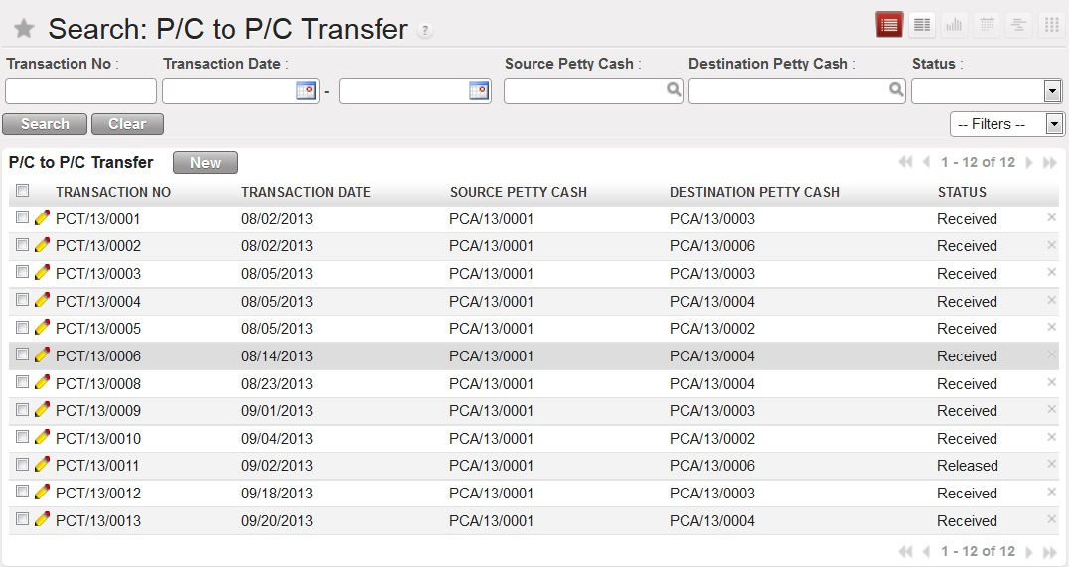

* 1. **Form View**

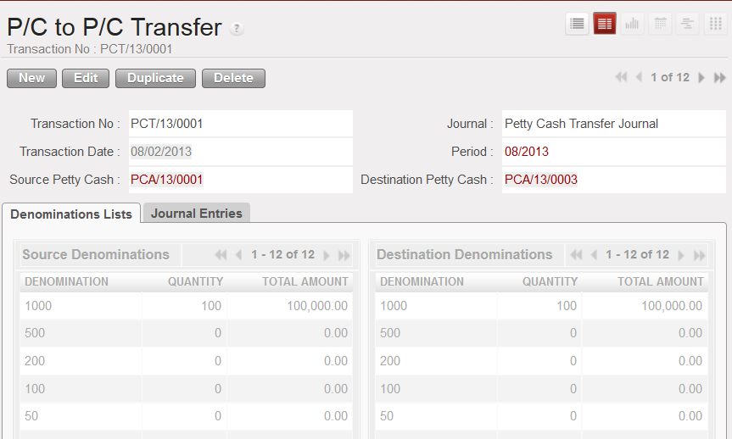

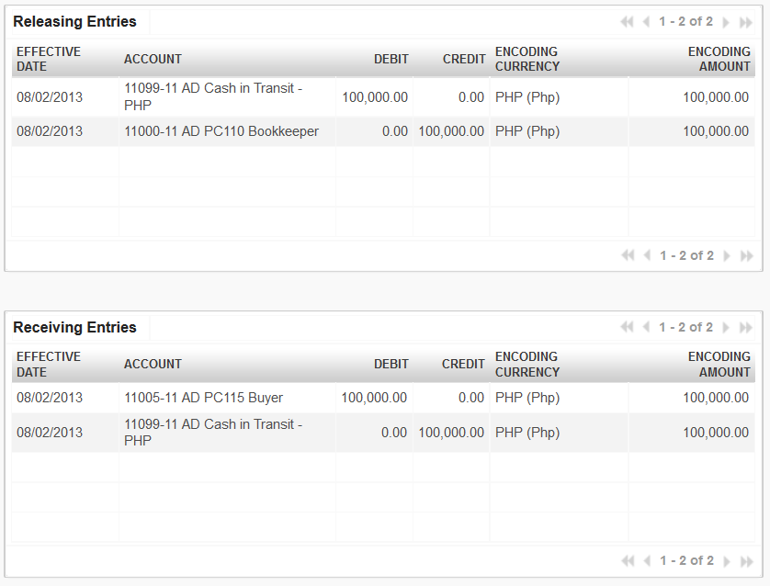

1. Menu and Access Right
   1. Menu – Bank and Cash > *Fund Transfers > P/C to P/C Transfer*
   2. Access Rights

|  |  |  |  |  |
| --- | --- | --- | --- | --- |
| **Role** | **Read** | **Write** | **Create** | **Delete** |
| **Petty Cash Administrator** | Yes | Yes | Yes | No |
| **Petty Cash Manager** | Yes | Yes | Yes | No |

1. Required Fields (required by State)

|  |  |
| --- | --- |
| **Field Name** | **Required in** |
| **Transaction Date** | Draft |
| **Source Petty Cash** | Draft |
| **Destination Petty Cash** | Draft |

1. Workflow



|  |  |  |
| --- | --- | --- |
| **State** | **Description** | **Visible Buttons** |
| **Draft** | Initial state of the document | **Confirm** |
| **Confirmed** | In this state, the source denomination is already changed based on what to be released. | **Release**  **Cancel** |
| **Released** | Journal entries for releasing the money from the account are already created. | **Receive**  **Cancel** |
| **Received** | Journal entries for receiving the money from the account are already created. | **Cancel** |
| **Cancelled** | No modifications will be made, cancellation of entries based on previous state and cash accounts reverted based on the released and received quantity. |  |

1. User Action

|  |  |  |
| --- | --- | --- |
| **Button** | **Action** | **Triggered By** |
| **Fill Denomination Lists** | Updates the denominations lists based on the currency of the petty cash account. | **Petty Cash Manager** |
| **Confirm** | Checking of the available funds based on the quantity of each source denomination. | **Petty Cash Administrator (Admin of Source Account)** |
| **Release** | Creation of releasing journal entries.  Change state to ‘**Released**’. | **Petty Cash Administrator (Admin of Source Account)** |
| **Receive** | Creation of receiving journal entries.  Change state to ‘**Received**. | **Petty Cash Administrator (Admin of Destination Account)** |
| **Cancel** | Removal of journal entry based on previous state.  Change state to ‘**Cancel**’.  Revert the cash counts based on previous state. | **Petty Cash Manager** |

1. Field Visibility

All fields are available for the Petty Cash Manager

1. Reports and Prints Outs

No Available Reports/Print Outs

1. Errors

|  |  |  |
| --- | --- | --- |
| **ERROR CODE** | **MESSAGE** | **SOLUTION** |
| PCT-001 | *Source and destination petty cash accounts have different currencies.* | Check the source and destination accounts. |
| PCT-002 | *Change the quantity of the denomination to transfer.* | Check for the quantity of the denomination to be transferred. |
| PCT-003 | *Quantity of the source denomination is less than the requested quantity.* | Check the quantity of the denomination to be transferred from the source petty cash. |
| PCT-004 | *You are not <user>! Only <User> can release/receive cash for this drawer!* | The user to process should be the manager of the petty cash. |
| PCT-005 | *Change the quantity of the denomination to receive!* | Check for the quantity of the denomination to be received. |
| PCT-006 | *Total amounts are not equal!* | Check the quantity of the denomination to be received. |

### Petty Cash to Bank

1. Purpose

Records the daily transactions created by Petty Cash managers.

1. Views
   1. **List View**

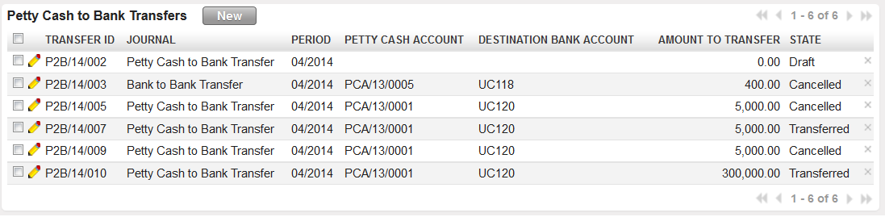

* 1. **Form View**

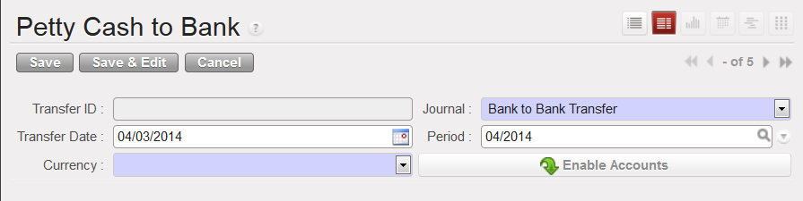

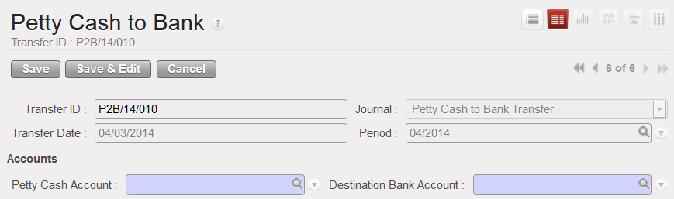

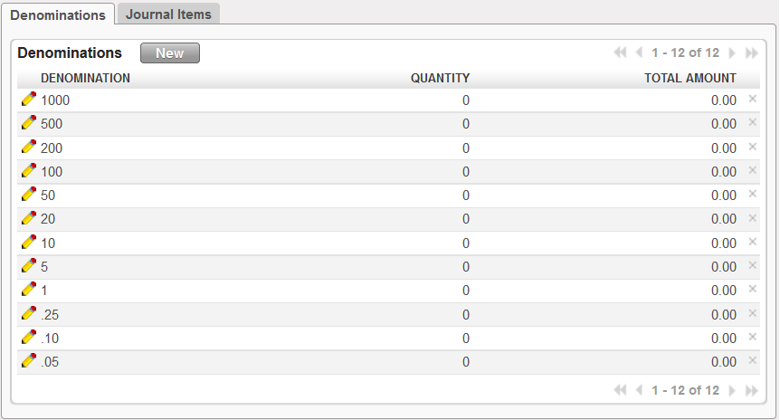

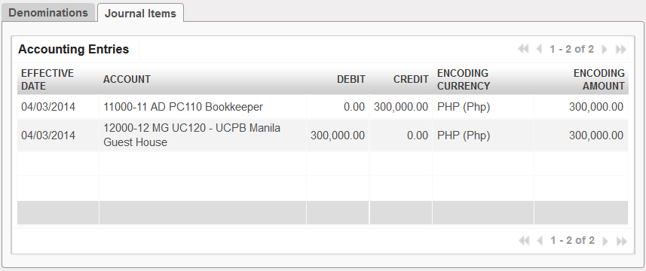

1. Menu and Access Right
   1. Menu – Bank and Cash > *Fund Transfers > Petty Cash to Bank*
   2. Access Rights

|  |  |  |  |  |
| --- | --- | --- | --- | --- |
| **Role** | **Read** | **Write** | **Create** | **Delete** |
| **Petty Cash Manager** | Yes | Yes | Yes | No |

1. Required Fields (required by State)

|  |  |
| --- | --- |
| **Field Name** | **Required in** |
| **Journal** | Draft and accounts disabled |
| **Currency** | Draft and accounts disabled |
| **Petty Cash Account** | Draft and accounts enabled |
| **Destination Bank Account** | Draft and accounts enabled |

1. Workflow



|  |  |  |
| --- | --- | --- |
| **State** | **Description** | **Visible Buttons** |
| **Draft** | Initial state of the document. | **Enable Accounts**  **Transfer**  **Cancel** |
| **Transferred** | In this state, the entries for the transfer have been created. Also, the denominations of the source petty cash have been updated.  State of the document is changed to ‘**Transferred**’. | **Cancel** |
| **Cancelled** | The changes on the petty cash denomination quantity were reverted. The created entries were also removed. |  |

1. User Action

|  |  |  |
| --- | --- | --- |
| **Button** | **Action** | **Triggered By** |
| **Enable Accounts** | Sets the visibility of the accounts and the tabs to True. Fills the denomination lists based on the chosen currency. | **Petty Cash Manager** |
| **Transfer** | Checks the source petty cash if the total amount is not less than or equal to zero.  Verifies if the quantity of the denomination to be release is less than or equal to the quantity of the source petty cash denomination.  Checks for negative quantities.  Creates journal entries  Deducts the quantity to release from the source petty cash. | **Petty Cash Manager** |
| **Cancel** | Removal of journal entry based on previous state.  Change state to ‘**Cancel**’. | **Petty Cash Manager** |

1. Field Visibility

All fields are available for the Petty Cash Manager

1. Reports and Prints Outs

No Available Reports/Print Outs

1. Errors

|  |  |  |
| --- | --- | --- |
| **ERROR CODE** | **MESSAGE** | **SOLUTION** |
| P2BFT-001 | *Insufficient funds on the chosen petty cash account!* | Choose another source petty cash account. |
| P2BFT-002 | *Please change the quantity of the denomination to be deducted from the petty cash account.* | Change the quantity of the denomination to be deducted. |
| P2BFT-003 | *Negative quantity on denomination list is not allowed!* | Change the quantity of the negative denomination. |
| P2BFT-004 | *The quantity of <denom> denomination of petty cash <pc> is less than the requested quantity to be transferred.* | Check first the denomination lists from the source petty cash account. |

### Internal Account Transfers

## Checks

### Check Payments

1. Purpose

Records the daily transactions created by Petty Cash managers.

1. Views
   1. **List View**

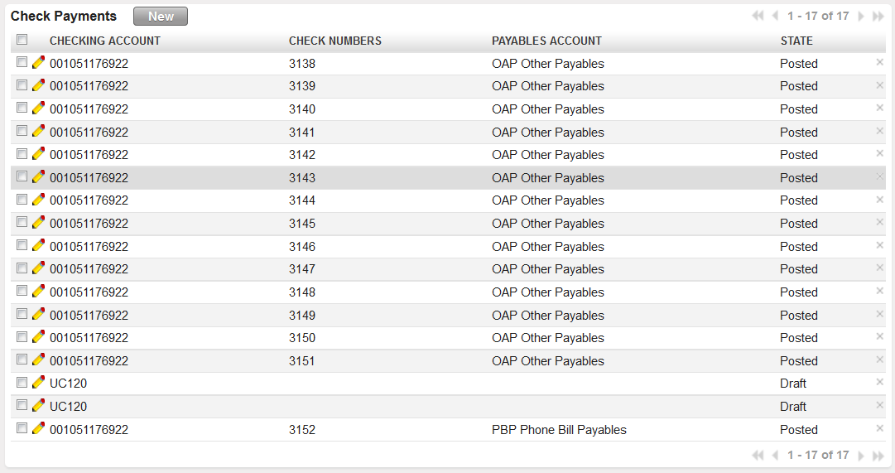

* 1. **Form View**

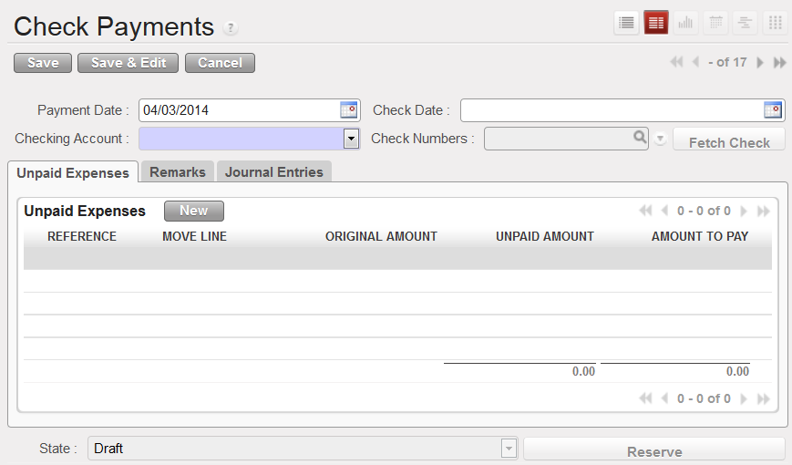

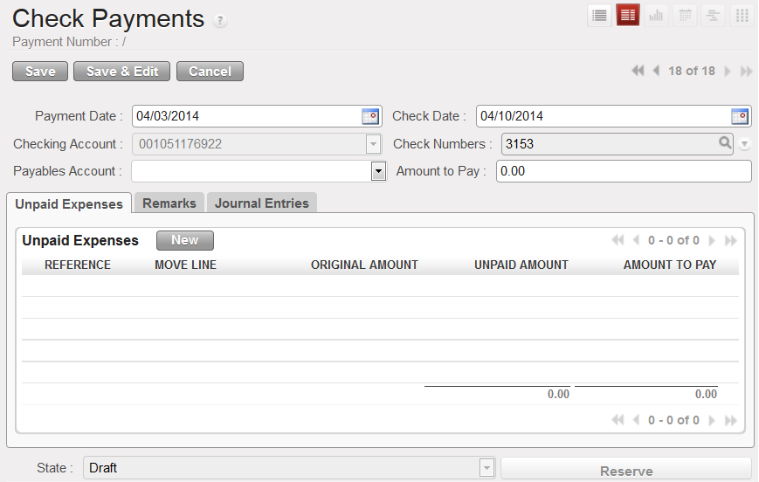

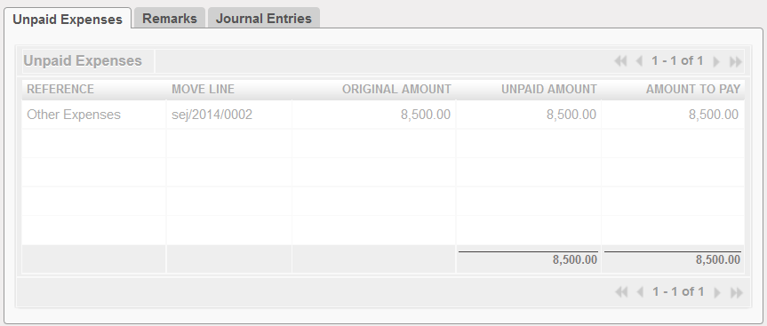

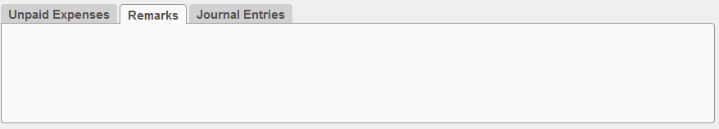

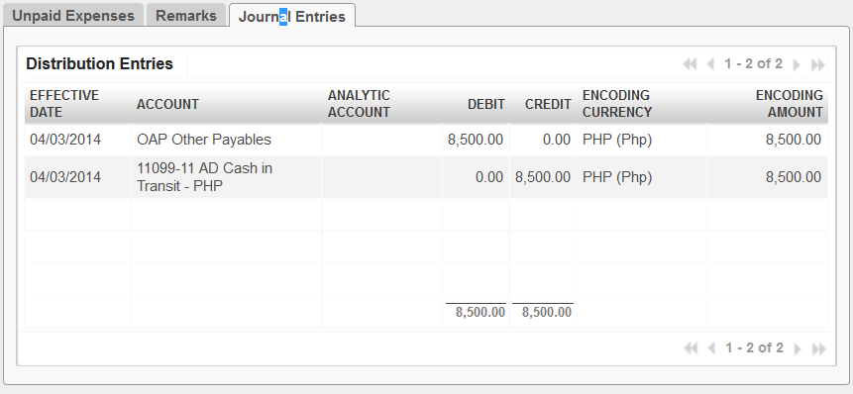

1. Menu and Access Right
   1. Menu – Bank and Cash> *Checks > Check Payments*
   2. Access Rights

|  |  |  |  |  |
| --- | --- | --- | --- | --- |
| **Role** | **Read** | **Write** | **Create** | **Delete** |
| **Check Manager** | Yes | Yes | Yes | No |

1. Required Fields (required by State)

|  |  |
| --- | --- |
| **Field Name** | **Required in** |
| **Checking Account** | Draft and accounts disabled |
| **Payables Account** | Draft and check number generated |
| **Amount to Pay** | Draft and check number generated |

1. Workflow



|  |  |  |
| --- | --- | --- |
| **State** | **Description** | **Visible Buttons** |
| **Draft** | Initial state of the document. | **Enable Accounts**  **Transfer**  **Cancel** |
| **Transferred** | In this state, the entries for the transfer have been created. Also, the denominations of the source petty cash have been updated.  State of the document is changed to ‘**Transferred**’. | **Cancel** |
| **Cancelled** | The changes on the petty cash denomination quantity were reverted. The created entries were also removed. |  |

1. User Action

|  |  |  |
| --- | --- | --- |
| **Button** | **Action** | **Triggered By** |
| **Enable Accounts** | Sets the visibility of the accounts and the tabs to True. Fills the denomination lists based on the chosen currency. | **Petty Cash Manager** |
| **Transfer** | Checks the source petty cash if the total amount is not less than or equal to zero.  Verifies if the quantity of the denomination to be release is less than or equal to the quantity of the source petty cash denomination.  Checks for negative quantities.  Creates journal entries  Deducts the quantity to release from the source petty cash. | **Petty Cash Manager** |
| **Cancel** | Removal of journal entry based on previous state.  Change state to ‘**Cancel**’. | **Petty Cash Manager** |

1. Field Visibility

All fields are available for the Petty Cash Manager

1. Reports and Prints Outs

No Available Reports/Print Outs

1. Errors

|  |  |  |
| --- | --- | --- |
| **ERROR CODE** | **MESSAGE** | **SOLUTION** |
| P2BFT-001 | *Insufficient funds on the chosen petty cash account!* | Choose another source petty cash account. |
| P2BFT-002 | *Please change the quantity of the denomination to be deducted from the petty cash account.* | Change the quantity of the denomination to be deducted. |
| P2BFT-003 | *Negative quantity on denomination list is not allowed!* | Change the quantity of the negative denomination. |
| P2BFT-004 | *The quantity of <denom> denomination of petty cash <pc> is less than the requested quantity to be transferred.* | Check first the denomination lists from the source petty cash account. |

### Check Monitoring

1. Purpose

Records the daily transactions created by Petty Cash managers.

1. Views
   1. **List View**
   2. **Form View**
2. Menu and Access Right
   1. Menu – Bank and Cash> *Checks > Check Payments*
   2. Access Rights

|  |  |  |  |  |
| --- | --- | --- | --- | --- |
| **Role** | **Read** | **Write** | **Create** | **Delete** |
| **Check Manager** | Yes | Yes | Yes | No |

1. Required Fields (required by State)

|  |  |
| --- | --- |
| **Field Name** | **Required in** |
| **Checking Account** | Draft and accounts disabled |
| **Currency** | Draft and accounts disabled |
| **Petty Cash Account** | Draft and accounts enabled |
| **Destination Bank Account** | Draft and accounts enabled |

1. Workflow



|  |  |  |
| --- | --- | --- |
| **State** | **Description** | **Visible Buttons** |
| **Draft** | Initial state of the document. | **Enable Accounts**  **Transfer**  **Cancel** |
| **Transferred** | In this state, the entries for the transfer have been created. Also, the denominations of the source petty cash have been updated.  State of the document is changed to ‘**Transferred**’. | **Cancel** |
| **Cancelled** | The changes on the petty cash denomination quantity were reverted. The created entries were also removed. |  |

1. User Action

|  |  |  |
| --- | --- | --- |
| **Button** | **Action** | **Triggered By** |
| **Enable Accounts** | Sets the visibility of the accounts and the tabs to True. Fills the denomination lists based on the chosen currency. | **Petty Cash Manager** |
| **Transfer** | Checks the source petty cash if the total amount is not less than or equal to zero.  Verifies if the quantity of the denomination to be release is less than or equal to the quantity of the source petty cash denomination.  Checks for negative quantities.  Creates journal entries  Deducts the quantity to release from the source petty cash. | **Petty Cash Manager** |
| **Cancel** | Removal of journal entry based on previous state.  Change state to ‘**Cancel**’. | **Petty Cash Manager** |

1. Field Visibility

All fields are available for the Petty Cash Manager

1. Reports and Prints Outs

No Available Reports/Print Outs

1. Errors

|  |  |  |
| --- | --- | --- |
| **ERROR CODE** | **MESSAGE** | **SOLUTION** |
| P2BFT-001 | *Insufficient funds on the chosen petty cash account!* | Choose another source petty cash account. |
| P2BFT-002 | *Please change the quantity of the denomination to be deducted from the petty cash account.* | Change the quantity of the denomination to be deducted. |
| P2BFT-003 | *Negative quantity on denomination list is not allowed!* | Change the quantity of the negative denomination. |
| P2BFT-004 | *The quantity of <denom> denomination of petty cash <pc> is less than the requested quantity to be transferred.* | Check first the denomination lists from the source petty cash account. |

## Exchanges

1. Purpose

Records the daily transactions created by Petty Cash managers.

1. Views
   1. **List View**
   2. **Form View**
2. Menu and Access Right
   1. Menu – Bank and Cash> *Checks > Check Payments*
   2. Access Rights

|  |  |  |  |  |
| --- | --- | --- | --- | --- |
| **Role** | **Read** | **Write** | **Create** | **Delete** |
| **Check Manager** | Yes | Yes | Yes | No |

1. Required Fields (required by State)

|  |  |
| --- | --- |
| **Field Name** | **Required in** |
| **Checking Account** | Draft and accounts disabled |
| **Currency** | Draft and accounts disabled |
| **Petty Cash Account** | Draft and accounts enabled |
| **Destination Bank Account** | Draft and accounts enabled |

1. Workflow



|  |  |  |
| --- | --- | --- |
| **State** | **Description** | **Visible Buttons** |
| **Draft** | Initial state of the document. | **Enable Accounts**  **Transfer**  **Cancel** |
| **Transferred** | In this state, the entries for the transfer have been created. Also, the denominations of the source petty cash have been updated.  State of the document is changed to ‘**Transferred**’. | **Cancel** |
| **Cancelled** | The changes on the petty cash denomination quantity were reverted. The created entries were also removed. |  |

1. User Action

|  |  |  |
| --- | --- | --- |
| **Button** | **Action** | **Triggered By** |
| **Enable Accounts** | Sets the visibility of the accounts and the tabs to True. Fills the denomination lists based on the chosen currency. | **Petty Cash Manager** |
| **Transfer** | Checks the source petty cash if the total amount is not less than or equal to zero.  Verifies if the quantity of the denomination to be release is less than or equal to the quantity of the source petty cash denomination.  Checks for negative quantities.  Creates journal entries  Deducts the quantity to release from the source petty cash. | **Petty Cash Manager** |
| **Cancel** | Removal of journal entry based on previous state.  Change state to ‘**Cancel**’. | **Petty Cash Manager** |

1. Field Visibility

All fields are available for the Petty Cash Manager

1. Reports and Prints Outs

No Available Reports/Print Outs

1. Errors

|  |  |  |
| --- | --- | --- |
| **ERROR CODE** | **MESSAGE** | **SOLUTION** |
| P2BFT-001 | *Insufficient funds on the chosen petty cash account!* | Choose another source petty cash account. |
| P2BFT-002 | *Please change the quantity of the denomination to be deducted from the petty cash account.* | Change the quantity of the denomination to be deducted. |
| P2BFT-003 | *Negative quantity on denomination list is not allowed!* | Change the quantity of the negative denomination. |
| P2BFT-004 | *The quantity of <denom> denomination of petty cash <pc> is less than the requested quantity to be transferred.* | Check first the denomination lists from the source petty cash account. |

## Configuration

### Currencies

1. Purpose

Records the daily transactions created by Petty Cash managers.

1. Views
   1. **List View**
   2. **Form View**
2. Menu and Access Right
   1. Menu – Bank and Cash> *Checks > Check Payments*
   2. Access Rights

|  |  |  |  |  |
| --- | --- | --- | --- | --- |
| **Role** | **Read** | **Write** | **Create** | **Delete** |
| **Check Manager** | Yes | Yes | Yes | No |

1. Required Fields (required by State)

|  |  |
| --- | --- |
| **Field Name** | **Required in** |
| **Checking Account** | Draft and accounts disabled |
| **Currency** | Draft and accounts disabled |
| **Petty Cash Account** | Draft and accounts enabled |
| **Destination Bank Account** | Draft and accounts enabled |

1. Workflow



|  |  |  |
| --- | --- | --- |
| **State** | **Description** | **Visible Buttons** |
| **Draft** | Initial state of the document. | **Enable Accounts**  **Transfer**  **Cancel** |
| **Transferred** | In this state, the entries for the transfer have been created. Also, the denominations of the source petty cash have been updated.  State of the document is changed to ‘**Transferred**’. | **Cancel** |
| **Cancelled** | The changes on the petty cash denomination quantity were reverted. The created entries were also removed. |  |

1. User Action

|  |  |  |
| --- | --- | --- |
| **Button** | **Action** | **Triggered By** |
| **Enable Accounts** | Sets the visibility of the accounts and the tabs to True. Fills the denomination lists based on the chosen currency. | **Petty Cash Manager** |
| **Transfer** | Checks the source petty cash if the total amount is not less than or equal to zero.  Verifies if the quantity of the denomination to be release is less than or equal to the quantity of the source petty cash denomination.  Checks for negative quantities.  Creates journal entries  Deducts the quantity to release from the source petty cash. | **Petty Cash Manager** |
| **Cancel** | Removal of journal entry based on previous state.  Change state to ‘**Cancel**’. | **Petty Cash Manager** |

1. Field Visibility

All fields are available for the Petty Cash Manager

1. Reports and Prints Outs

No Available Reports/Print Outs

1. Errors

|  |  |  |
| --- | --- | --- |
| **ERROR CODE** | **MESSAGE** | **SOLUTION** |
| P2BFT-001 | *Insufficient funds on the chosen petty cash account!* | Choose another source petty cash account. |
| P2BFT-002 | *Please change the quantity of the denomination to be deducted from the petty cash account.* | Change the quantity of the denomination to be deducted. |
| P2BFT-003 | *Negative quantity on denomination list is not allowed!* | Change the quantity of the negative denomination. |
| P2BFT-004 | *The quantity of <denom> denomination of petty cash <pc> is less than the requested quantity to be transferred.* | Check first the denomination lists from the source petty cash account. |

### Denominations

1. Purpose

Records the daily transactions created by Petty Cash managers.

1. Views
   1. **List View**
   2. **Form View**
2. Menu and Access Right
   1. Menu – Bank and Cash> *Checks > Check Payments*
   2. Access Rights

|  |  |  |  |  |
| --- | --- | --- | --- | --- |
| **Role** | **Read** | **Write** | **Create** | **Delete** |
| **Check Manager** | Yes | Yes | Yes | No |

1. Required Fields (required by State)

|  |  |
| --- | --- |
| **Field Name** | **Required in** |
| **Checking Account** | Draft and accounts disabled |
| **Currency** | Draft and accounts disabled |
| **Petty Cash Account** | Draft and accounts enabled |
| **Destination Bank Account** | Draft and accounts enabled |

1. Workflow



|  |  |  |
| --- | --- | --- |
| **State** | **Description** | **Visible Buttons** |
| **Draft** | Initial state of the document. | **Enable Accounts**  **Transfer**  **Cancel** |
| **Transferred** | In this state, the entries for the transfer have been created. Also, the denominations of the source petty cash have been updated.  State of the document is changed to ‘**Transferred**’. | **Cancel** |
| **Cancelled** | The changes on the petty cash denomination quantity were reverted. The created entries were also removed. |  |

1. User Action

|  |  |  |
| --- | --- | --- |
| **Button** | **Action** | **Triggered By** |
| **Enable Accounts** | Sets the visibility of the accounts and the tabs to True. Fills the denomination lists based on the chosen currency. | **Petty Cash Manager** |
| **Transfer** | Checks the source petty cash if the total amount is not less than or equal to zero.  Verifies if the quantity of the denomination to be release is less than or equal to the quantity of the source petty cash denomination.  Checks for negative quantities.  Creates journal entries  Deducts the quantity to release from the source petty cash. | **Petty Cash Manager** |
| **Cancel** | Removal of journal entry based on previous state.  Change state to ‘**Cancel**’. | **Petty Cash Manager** |

1. Field Visibility

All fields are available for the Petty Cash Manager

1. Reports and Prints Outs

No Available Reports/Print Outs

1. Errors

|  |  |  |
| --- | --- | --- |
| **ERROR CODE** | **MESSAGE** | **SOLUTION** |
| P2BFT-001 | *Insufficient funds on the chosen petty cash account!* | Choose another source petty cash account. |
| P2BFT-002 | *Please change the quantity of the denomination to be deducted from the petty cash account.* | Change the quantity of the denomination to be deducted. |
| P2BFT-003 | *Negative quantity on denomination list is not allowed!* | Change the quantity of the negative denomination. |
| P2BFT-004 | *The quantity of <denom> denomination of petty cash <pc> is less than the requested quantity to be transferred.* | Check first the denomination lists from the source petty cash account. |

### Banks

1. Purpose

Records the daily transactions created by Petty Cash managers.

1. Views
   1. **List View**
   2. **Form View**
2. Menu and Access Right
   1. Menu – Bank and Cash> *Checks > Check Payments*
   2. Access Rights

|  |  |  |  |  |
| --- | --- | --- | --- | --- |
| **Role** | **Read** | **Write** | **Create** | **Delete** |
| **Check Manager** | Yes | Yes | Yes | No |

1. Required Fields (required by State)

|  |  |
| --- | --- |
| **Field Name** | **Required in** |
| **Checking Account** | Draft and accounts disabled |
| **Currency** | Draft and accounts disabled |
| **Petty Cash Account** | Draft and accounts enabled |
| **Destination Bank Account** | Draft and accounts enabled |

1. Workflow



|  |  |  |
| --- | --- | --- |
| **State** | **Description** | **Visible Buttons** |
| **Draft** | Initial state of the document. | **Enable Accounts**  **Transfer**  **Cancel** |
| **Transferred** | In this state, the entries for the transfer have been created. Also, the denominations of the source petty cash have been updated.  State of the document is changed to ‘**Transferred**’. | **Cancel** |
| **Cancelled** | The changes on the petty cash denomination quantity were reverted. The created entries were also removed. |  |

1. User Action

|  |  |  |
| --- | --- | --- |
| **Button** | **Action** | **Triggered By** |
| **Enable Accounts** | Sets the visibility of the accounts and the tabs to True. Fills the denomination lists based on the chosen currency. | **Petty Cash Manager** |
| **Transfer** | Checks the source petty cash if the total amount is not less than or equal to zero.  Verifies if the quantity of the denomination to be release is less than or equal to the quantity of the source petty cash denomination.  Checks for negative quantities.  Creates journal entries  Deducts the quantity to release from the source petty cash. | **Petty Cash Manager** |
| **Cancel** | Removal of journal entry based on previous state.  Change state to ‘**Cancel**’. | **Petty Cash Manager** |

1. Field Visibility

All fields are available for the Petty Cash Manager

1. Reports and Prints Outs

No Available Reports/Print Outs

1. Errors

|  |  |  |
| --- | --- | --- |
| **ERROR CODE** | **MESSAGE** | **SOLUTION** |
| P2BFT-001 | *Insufficient funds on the chosen petty cash account!* | Choose another source petty cash account. |
| P2BFT-002 | *Please change the quantity of the denomination to be deducted from the petty cash account.* | Change the quantity of the denomination to be deducted. |
| P2BFT-003 | *Negative quantity on denomination list is not allowed!* | Change the quantity of the negative denomination. |
| P2BFT-004 | *The quantity of <denom> denomination of petty cash <pc> is less than the requested quantity to be transferred.* | Check first the denomination lists from the source petty cash account. |

# Accounting

## Journal Entries

### Journal Entries

### Journal Items

### Analytic Journal Items

## Charts

### Chart of Accounts

### Chart of Analytic Accounts

## Periodical Processing

### Opening Balance

### Recurring Entries

### End of Period

#### Close a Period

#### Close a Fiscal Year

### Fund Allocation

### Revaluations

#### Monthly Revaluation

## Reporting

### Statement of Accounts

#### Statements

#### Statement Requests

### Regional Reports

#### Generate Regional Report

#### Regional Profit and Loss

#### Regional Entries

#### Regional Uploader

## Configuration

### Financial Accounting

#### Periods

#### Journals

#### Accounts

### Analytic Accounting

#### Analytic Journals

#### Analytic Accounts

### ACCPAC Extension Tools

### Miscellaneous

# Administration